Arab Open University – Egypt branch



Faculty of Computer Studies
Data Science Department

Forecasting stock market movement using sentiment analysis

By: Osama Mohamed Alawadi Elsaeed
ID: 2051822264

TM471: Final Year Project, December 2024

Supervisors
Sara Nabil
Nisreen Osman

Abstract
The stock market is deeply influenced by human behavior, as investor sentiment often drives trends and price movements. This project presents a sentiment analysis system designed to evaluate financial news, social media posts, and market-related textual data. By leveraging Natural Language Processing (NLP) techniques and machine learning models, the system quantifies market sentiment to provide actionable insights.
The model is trained on a diverse dataset of financial texts, including news articles, earnings reports, and social media commentary. Utilizing domain-specific lexicons and advanced algorithms, it effectively identifies bullish, bearish, or neutral sentiment, automating an otherwise resource-intensive task.
This tool empowers traders, analysts, and investors by delivering real-time sentiment-driven insights, enabling data-driven strategies and enhanced decision-making. It highlights the significant role of AI in analyzing psychological factors, which are essential for navigating the complexities of financial markets.

Acknowledgment
It’s my pleasure to thank all the professionals who helped me implement this project. Most importantly I extend my most heartfelt thanks to Sara Nabil & Nisreen Osman (My supervisor) whose support and guidance were of immense help during this work.

Preface
1 Introduction 9
1.1 Overview ……………………………………………………………………………………………………..……………….……… 9
1.2 Problem Statement …………………………………………………………………………………………………………………… 9
1.3 Aims and Objectives …………………………………………………………………………………………………………………. 10
1.3.1 Aims …………………………………………………………………………………………………………………….. 10
1.3.2 Objectives ……………………………………………………………………………………………………………….. 10
1.4 Motivation …………………………………………………………………………………………………………………………… 10
1.5 Project Scope …………………………………………………………………….…………….…………….…………….………… 11
2 Literature Overview 12
2.1 Introduction …………………………………………………………………….………….………….………….…………………… 12
2.2 Scope and Objectives …………………………………………………………………….………….………….………….…….…… 12
2.2.1 Foundation of sentiment analysis ……………………………………………………………………………..………….. 12
2.2.1.1 Definition And purpose ………………………..………….………….………….………………….……….. 12
2.2.1.2 Sentiment Representation (Types of Sentiment) ………….………….………….………….……………….. 12
2.2.1.3 Text Preprocessing ………….………….………….………….………….………….……………………….. 13
2.2.1.4 Feature Extraction ………….………….………….………….………….………….……………….……….. 13
2.2.1.5 Sentiment Classification Approaches ………….………….………….………….…………………………... 13
2.2.1.6 Evaluate ………….………….………….………….………….………….………….………….……..……... 13
2.2.1.7 Applications in stock market analysis ………….………….………….………….…………………………... 14
2.3 Similar Technologies …………………………………………………………………….………….………….……………………… 14
2.3.1 Bloomberg terminal …………………………………………………………………………………....………….………. 14
2.3.1.1 Introduction …………………………………………………………………….………….………………….. 14
2.3.1.2 Similarity and differences ………………………………………………………………………….…………. 14
2.3.1.3 Advantages and disadvantages of Bloomberg Terminal ………………………………….………………….. 14
2.3.1.4 Advantages and disadvantages of My Model ………………………………………………………………… 14
2.3.2 Reuters power of APIs …………………………………………………………………….………….…………..……….. 15
2.3.2.1 Introduction …………………………………………………………………….………….…………..……… 15
2.3.2.2 Similarity and differences ………………………………………………………………………….…………. 15
2.3.2.3 Advantages and disadvantages of Reuters APIs …………………………………………….………………... 15
2.3.2.4 Advantages and disadvantages of My Model ………………………………………………………………… 15
2.3.3 Fact-Set …………………………………………………………………….………….………….………….……………. 16
2.3.3.1 Introduction …………………………………………………………………….………….…………..……… 16
2.3.3.2 Similarity and differences ………………………………………………………………………….…………. 16
2.3.3.3 Advantages and disadvantages of Fact-Set …………………………………………………..……………….. 16
2.3.3.4 Advantages and disadvantages of My Model ………………………………………………………………… 16
2.4 Using Flow-Chart to explain work one of similar technologies (Bloomberg Terminal) ……………………..………………………... 17
2.4.1 Introduction …………………………………………………………………………………………………………..……. 17
2.4.2 Workflow ………………………………………………………………………………………………………………….. 17
2.4.3 Flowchart ……………………………………………………………………………………………………………..…… 18
3 Requirements and Analysis 19
3.1 Introduction …………………………………………………………………….………………………………………………….…… 19
3.2 Requirements …………………………………………………………………….……………………………………………….……. 19
3.2.1 Functional Requirements …………………………………………………………………….………………….………… 19
3.2.1.1 Data Processing …………………………………………………………………….………………………….. 19
3.2.1.2 Sentiment Classification …………………………………………………………………….……..…………. 19
3.2.1.3 Real-Time Processing …………………………………………………………………….………….……….. 19
3.2.1.4 Prediction integration …………………………………………………………………….………….………... 19
3.2.2 Non-Functional Requirements …………………………………………………………………….…………..…………… 19
3.2.2.1 Performance …………………………………………………………………….……………………..………. 19
3.2.2.2 Scalability …………………………………………………………………….……………………………….. 19
3.2.2.3 Adaptability …………………………………………………………………….……………………….…….. 20
3.2.2.4 Robustness …………………………………………………………………….……………………….……… 20
3.2.2.5 Explainability …………………………………………………………………….……………………..……... 20
3.2.3 Data Requirements …………………………………………………………………….…………………………………… 20
3.2.3.1 Dataset Collection …………………………………………………………………….………………………. 20
3.2.3.2 Labeling …………………………………………………………………….………………………………… 20
3.2.3.3 Diversity …………………………………………………………………….………………………………… 20
3.3 Analysis …………………………………………………………………….………………………………………………………….. 20
3.3.1 Input Data Analysis …………………………………………………………………….…………………………………. 20
3.3.1.1 Data Types …………………………………………………………………….……………………………… 20
3.3.1.2 Data Challenges …………………………………………………………………….………………………… 20
3.3.2 Feature Engineering …………………………………………………………………….…………………………………. 20
3.3.2.1 Text Features …………………………………………………………………….……………………………. 20
3.3.2.2 Financial Features …………………………………………………………………….……………………….. 20
3.3.3 Model Architecture Analysis …………………………………………………………………….………………………… 20
3.3.3.1 Traditional Models …………………………………………………………………….……………………… 21
3.3.3.2 Deep Learning Models …………………………………………………………………….………………….. 21
3.3.3.3 Hybrid Models …………………………………………………………………….………………………….. 21
3.3.4 Evaluation Metrics …………………………………………………………………….…………………………………… 21
3.3.4.1 Classification Metrics …………………………………………………………………….…………………… 21
3.3.4.2 Prediction Metrics …………………………………………………………………….………………………. 21
3.3.4.3 Latency Metrics …………………………………………………………………….…………………………. 21
3.3.5 Risk Analysis …………………………………………………………………….………………………………………… 21
3.3.5.1 Overfitting …………………………………………………………………….……………………………….. 21
3.3.5.2 Domain-Specific Errors …………………………………………………………………….…………………. 21
3.3.5.3 Bias in Data …………………………………………………………………….……………………………... 21
3.4 Implementation Plan Based on Requirements and Analysis …………………………………………………………………………... 21
3.5 Use case: Sentiment Analysis Model for Stock Market Prediction ……………………………………………………………………. 22
3.5.1 problem Statement …………………………………………………………………….…………………………………. 22
3.5.2 Solution Overview …………………………………………………………………….………………………………….. 22
3.5.3 Scenario: Predicting Stock Price Movements Using Social Media Sentiment …………………………………………. 22
3.5.3.1 Objective …………………………………………………………………….……………………………… 22
3.5.3.2 Inputs …………………………………………………………………….…………………………………. 22
3.5.3.3 Steps …………………………………………………………………….………………………………….. 22
3.5.3.4 Outputs …………………………………………………………………….……………………………….. 22
3.5.3.5 Use by Investors …………………………………………………………………….……………………… 23
3.5.4 Result and Benefits …………………………………………………………………….……………………………….. 23
3.5.5 Potential Results …………………………………………………………………….……………………….. 23
4 Design, Implementation, and Testing 24
4.1 Introduction …………………………………………………………………………………………………………………………. 24
4.2 Design ………………………………………………………………………………………………………………………………. 24
4.2.1 Problem Definition …………………………………………………………………………………………………….. 25
4.2.2 Data Collection And preparation ………………………………………………………………………………………. 25
4.2.3 Feature Selection and Engineering …………………………………………………………………………………….. 25
4.2.4 Design Objectives ……………………………………………………………………………………………………… 25
4.2.5 Design Trade-offs ……………………………………………………………………………………………………… 25
4.2.6 Interpretability and Explainability ……………………………………………………………………………………. 26
4.2.7 Deployment Considerations ……………………………………………………………………………………………….. 26
4.3 Implementation ………………………………………………………………………………………………………………………… 27
4.3.1 Data Sources ……………………………………………………………………………………………………………… 27
4.3.1.1 Scraping Articles ……………………………………………………………………………………………. 27
4.3.1.2 Scraping articles with URL and class ……………………………………………………………………….. 28
4.3.1.3 Extract links in specific link ………………………………………………………………………………… 29
4.3.1.4 Special Algorithms ………………………………………………………………………………………….. 31
4.3.1.5 URL Validation …………………………………………………………………………………………….. 32
4.3.1.6 Extract Date ………………………………………………………………………………………………… 33
4.3.1.7 Date Validation ……………………………………………………………………………………………… 34
4.3.1.8 Special Dates ……………………………………………………………………………………………….. 35
4.3.1.9 URLs ………………………………………………………………………………………………………. 36
4.3.1.10 News Aggregation Script ………………………………………………………………………………….. 37
4.3.1.11 Preprocessor and its integration ……………………………………………………………………………. 38
4.3.1.12 Extract Dates ……………………………………………………………………………………………….. 39
4.3.2 Text Cleaning …………………………………………………………………………………………………………….. 40
4.3.2.1 Convert Date …………………………………………………………………………………………………. 40
4.3.2.2 Repeated patterns …………………………………………………………………………………………….. 41
4.3.2.3 Format Date ………………………………………………………………………………………………… 42
4.3.2.4 Filter source data …………………………………………………………………………………………… 43
4.3.2.5 Text Cleaning ……………………………………………………………………………………………… 43
4.3.2.6 Handling Stock Symbols and Financial Terms …………………………………………………………….. 44
4.3.2.7 Textual Features ……………………………………………………………………………………………. 44
4.3.2.7.1 TF-IDF (Term frequency – inverse document frequency) …………………………………….. 44
4.3.2.8 Tokenization ………………………………………………………………………………………………… 44
4.3.2.9 Sentiment Lexicons ………………………………………………………………………………………… 44
4.3.2.10 Labeling sentiment Lexicons ……………………………………………………………………………… 45
4.3.2.11 Process of Training Model ………………………………………………………………………………… 45
4.3.2.11.1 Training model using BPE ………………………………………………………………………. 45
4.3.2.11.2 Feature Extraction ………………………………………………………………………………. 47
4.3.2.11.3 Model Training (Logistic Regression) ………………………………………………………...... 48
4.3.2.11.4 Evaluation Training ………………………………………………………………………………48
4.4 Testing ………………………………………………………………………………………………………………………………… 49
4.4.1 Evaluation ………………………………………………………………………………………………………………… 49
4.4.2 Deployment and Prediction ……………………………………………………………………………………………….. 49
4.4.3 Results …………………………………………………………………………………………………………………….. 52
4.4.3.1 Training and Testing Evaluation ……………………………………………………………………………... 52
4.4.3.2 Stock analysis ………………………………………………………………………………………………… 53
5 Result and Discussion 55
5.1 introduction …………………………………………………………………….……….……….……….……….……….……….…... 55
5.2 Finding …………………………………………………………………….……….……….……….……….……….……….……….. 55
5.2.1 Sentiment Analysis Results …………………………………………………………………….……….……….……….. 55
5.2.2 Predictive Model Performance …………………………………………………………………….……….……….……. 55
5.2.3 Unexpected findings …………………………………………………………………….……….……….……….…….. 55
5.2.4 Off-Topic Findings …………………………………………………………………….……….……….……….………… 55
5.3 Goals Achieved …………………………………………………………………….……….……….……….……….……….……….. 56
5.3.1 Primary Goals …………………………………………………………………….……….……….……….……….…….. 56
5.3.2 Secondary Goals …………………………………………………………………….……….……….……….……….….. 56
5.3.3 Challenges and Partial Goals …………………………………………………………………….……….……….……… 56
5.4 Further Work …………………………………………………………………….……….……….……….……….…………………. 56
5.4.1 New Investigation Areas …………………………………………………………………….……….……….………….. 56
5.4.2 Incomplete Work …………………………………………………………………….……….……….……….…………. 56
5.5 Ethical, Legal and Social Issues …………………………………………………………………….……….……….……….……… 57
5.5.1 Ethical Issues …………………………………………………………………….……….……….……….……….…… 57
5.5.2 Legal Issue …………………………………………………………………….……….……….……….……….………. 57
5.5.3 Social Issues …………………………………………………………………….……….……….……….……….…… 57
6 Conclusions 58
6.1 Introduction …………………………………………………………………….……….……….……….……….……….………….. 58
6.2 Key Findings …………………………………………………………………….……….……….……….……….……….………… 58
6.2.1 Sentiment Analysis Model Performance …………………………………………………………………….…………... 58
6.2.2 Predictive Power for Stock Price Movements …………………………………………………………………………… 58
6.2.3 Challenges and Limitations …………………………………………………………………….……….……….………. 58
6.3 Goal Achieved …………………………………………………………………….……….……….……….……….……….………. 59
6.4 Implications and Contributions …………………………………………………………………….……….……….……….……….. 59
6.5 Reinforcing Sentiment’s influence on the Stock Market ……………………………………………………………….……….……. 59
6.7 Challenges as Opportunities …………………………………………………………………….……….……….……….……….….. 59
6.8 Practical Implications and Applications …………………………………………………………………….……….……….……….. 60
6.5 Future Work …………………………………………………………………….……….……….……….……….……….………….. 60

Chapter 1: Introduction
1.1 Overview
Understanding market sentiment is vital for risk management, as psychological factors significantly influence stock price movements. This project develops a risk management tool that combines sentiment analysis with technical indicators like Moving Average (MA) and Relative Strength Index (RSI).
Using Natural Language Processing (NLP) and machine learning, the sentiment analysis component processes financial news, social media, and market texts, categorizing sentiment as bullish, bearish, or neutral. MA identifies price trends, while RSI highlights overbought or oversold conditions. Together, these tools provide a comprehensive view of psychological and quantitative market dynamics.
The project bridges the gap between behavioral finance and traditional metrics, offering investors actionable insights, enhanced predictive accuracy, and reduced emotional bias. It empowers traders, analysts, and institutions with a modern, data-driven approach to stock market decision-making.
1.2 Problem Statement
Effective risk management in the stock market requires analyzing both quantitative metrics and psychological factors like investor sentiment, which significantly influence supply and demand dynamics. Manual analysis of vast data from financial news, social media, and market reports is impractical, leading to missed opportunities.
While technical indicators such as Moving Averages (MA) and Relative Strength Index (RSI) are widely used, they fail to incorporate sentiment analysis, creating a gap in comprehensive market risk assessment.
This project addresses this issue by developing a sentiment-based risk management tool that integrates sentiment analysis with MA and RSI, providing investors with a holistic view of market conditions to enhance decision-making and minimize risks in volatile markets.

1.3 Aims and Objectives
1.3.1 Aims:
The primary aim of this project is to develop an advanced risk management tool for the stock market that integrates sentiment analysis with technical indicators like Moving Averages (MA) and Relative Strength Index (RSI). This tool seeks to provide investors with a comprehensive understanding of market conditions by combining psychological insights with quantitative metrics, ultimately enhancing decision-making and minimizing investment risks.
    - Objectives:
- Develop a Sentiment Analysis Model:
Build a machine learning-based Natural Language Processing (NLP) system to analyze and quantify market sentiment from financial news, social media posts, and other textual data sources.
- integrate Technical Indicators:
Incorporate Moving Averages and Relative Strength Index as complementary tools to assess price trends and market momentum.
- Combine Sentiment and Technical Analysis:
Develop an integrated framework that fuses sentiment data with traditional technical indicators to provide a more holistic market analysis.
- Design a User-Friendly Dashboard:
Create a visual interface that allows users to monitor sentiment trends, MA, and RSI indicators for stocks like Tesla, Google, and others in real time.
- Evaluate Model Accuracy and Performance:
Test the tool’s effectiveness using historical market data and assess its predictive capability for identifying market risks and opportunities.
- Enhance Risk Management Strategies:
Offer actionable insights that assist investors in making data-driven decisions while reducing emotional bias and improving portfolio performance.
1.4 Motivation
The stock market is influenced by numerous factors, including economic data, company performance, and investor sentiment. While technical indicators are commonly used, they often overlook the impact of market psychology. This project addresses this gap by integrating sentiment analysis with traditional tools like Moving Averages (MA) and Relative Strength Index (RSI) to provide a holistic view of market dynamics.
Advances in Artificial Intelligence (AI) and Natural Language Processing (NLP) enable automated sentiment analysis from vast unstructured data, such as news and social media, revealing actionable insights. By combining psychological and quantitative factors, this tool reduces emotional bias, enhances decision-making, and contributes to smarter risk management in volatile markets like Tesla and Google. Ultimately, the project bridges behavioral finance and technical analysis, fostering data-driven investment strategies.

1.5 Project Scope
This project focuses on developing an integrated risk management tool for the stock market that combines sentiment analysis with traditional technical indicators. The tool aims to provide investors, traders, and analysts with actionable insights for informed decision-making and enhanced portfolio management. The key aspects of the project scope are outlined below:
- Sentiment Analysis Component:
  - Utilize Natural Language Processing (NLP) and machine learning models to analyze financial news, social media content, and market-related texts.
  - Quantify sentiment into bullish, bearish, or neutral categories to reflect market psychology.
- Technical Indicators Integration:
  - Implement Moving Averages (MA) to identify stock price trends over various time periods.
  - Use Relative Strength Index (RSI) to assess stock momentum and detect overbought or oversold conditions.
- Data Sources and Processing:
  - Collect and preprocess data from financial news websites, social media platforms, and stock market APIs.
  - Curate a historical dataset for training, validation, and testing of sentiment analysis models.
- System Design and Development:
  - Create a framework that integrates sentiment scores with MA and RSI to generate a composite risk indicator.
  - Design a user-friendly interface or dashboard to visualize sentiment trends and technical indicators in real-time.
- Evaluation and Validation:
  - Test the tool using historical data for stocks like Tesla and Google to evaluate its predictive accuracy and reliability.
  - Compare results with traditional methods to demonstrate the added value of sentiment integration.
- Limitations and Future Extensions:
  - Acknowledge potential limitations, such as data availability, model accuracy, and real-time performance.
  - Outline future enhancements, such as expanding coverage to other asset classes and incorporating additional indicators or sentiment dimensions.

Chapter 2 Literature Overview
  - introduction:
The stock market is influenced by various factors, including macroeconomic indicators, political events, and public sentiment. Among these, sentiment expressed in financial news, analyst reports, and social media has become a key determinant of market trends. Understanding and quantifying sentiment provides valuable insights, aiding investors in making more informed decisions.
With advancements in big data and natural language processing (NLP), sentiment analysis has become an effective tool for extracting insights from unstructured text. By analyzing opinions and emotional cues, sentiment analysis helps identify market sentiment (positive, negative, or neutral) toward stocks, sectors, or the broader market. This is crucial in algorithmic trading, where quick access to actionable information can provide a competitive advantage.
This overview explores the evolution and application of sentiment analysis in stock market prediction, reviewing foundational research, modern methodologies, and the integration of sentiment analysis with machine learning. It also addresses challenges such as noisy data, linguistic nuances, and biases in textual sources, laying a foundation for the project’s contributions to this field.
  - Scope and Objectives:
2.2.1 Foundation of sentiment analysis:
2.2.1.1 Definition and purpose:
Sentiment analysis involves determining the emotional tone behind a body of text, categorizing it as positive, negative, or neutral (or along a finer-grained scale). In the stock market context, sentiment analysis aims to understand the market’s mood and how public sentiment influences stock prices, investment decisions, and financial trends.
2.2.1.2 Sentiment Representation (Types of Sentiment): (1)
Binary Classification: Sentiments are categorized as positive or negative.
Multi-class Classification: Adds a neutral category or further distinctions (e.g., highly positive, somewhat positive).
Sentiment Scoring: Assigns a continuous score to measure sentiment intensity, typically ranging from -1 to 1.
Textual Context: Sentiments depend on the context and domain; the same phrase may carry different implications in finance compared to casual conversations.

(1) Sebastian Raschka, and Yuxi Liu, and Vahid Mirjalili. (2022), Machine Learning wit PyTorch and Scikit-Learn, 1th edition, Birmingham: Packt publishing Ltd.
2.2.1.3 Text preprocessing: (1)
Text data is unstructured and noisy, requiring preprocessing to ensure consistency and quality. And it contain key this key steps:
Tokenization: Splitting text into words or phrases.
Lowercasing: Standardizing text by converting to lowercase.
Stop-word Removal: Removing common words that don't carry sentiment.
Stemming/Lemmatization: Reducing words to their base forms ("investing" → "invest").
Noise Removal: Removing URLs, special characters, and irrelevant text.
2.2.1.4 Feature Extraction:
Sentiment analysis relies on converting text into numerical features that models can process. Some common techniques:
Bag-of-Words (BoW): Represents text as a frequency distribution of words. (1)
TF-IDF (Term Frequency-Inverse Document Frequency): Weighs word importance relative to its frequency in a corpus. (1)
Word Embeddings: Dense vector representations of words capturing semantic meaning (e.g., Word2Vec, GloVe, FastText).
2.2.1.5 Sentiment Classification Approaches:
Sentiment classification is performed using various computational approaches:
Lexicon-Based Approaches: That Use predefined dictionaries of positive and negative words to assign sentiment scores. Like using financial lexicons like Loughran-McDonald.
Machine Learning Approaches: Train models using labeled datasets to classify sentiment. Like using Algorithms include logistic regression, support vector machines (SVM), and decision trees. (1)
Deep Learning Approaches: Use neural networks to capture complex patterns in data. Popular architectures include RNNs, LSTMs, CNNs, and transformer-based models like BERT.
2.2.1.6 Evaluate metrics:
Sentiment analysis models are evaluated based on their ability to classify or predict sentiment accurately. Example of key metrics:
Accuracy: Percentage of correctly classified instances.
Precision, Recall, and F1-Score: Measure performance on positive and negative classes.
Confusion Matrix: Summarizes the performance of model on different sentiment classes.

(1) Sebastian Raschka, and Yuxi Liu, and Vahid Mirjalili. (2022), Machine Learning wit PyTorch and Scikit-Learn, 1th edition, Birmingham: Packt publishing Ltd.
(2) Daniel Jurafsky, and James H.Martin. (2024), Speech and Language Processing, 3th edition, Stanford: Stanford University.
2.2.1.7 Applications in stock market analysis:
Text Sources: Financial news articles, social media platforms (e.g., Twitter), analyst reports, and stock forums.
Sentiment Implications: Positive sentiment often correlates with upward stock movement, while negative sentiment might indicate a potential downturn.
Key Challenges: Handling domain-specific jargon, sarcasm, and ambiguous language.
2.3 Similar Technologies:
    - Bloomberg terminal:
2.3.1.1 Introduction:
The Bloomberg Terminal revolutionized the industry by bringing transparency to financial markets. More than four decades on, it remains at the cutting edge of innovation and information delivery — with fast access to news, data, unique insight, and trading tools helping leading decision-makers turn knowledge into action. (1)
The terminal provides coverage of markets, industries, companies & securities across all asset classes. In addition drive innovation and productivity with connected data and technology built for how it works.
2.3.1.2 Similarity and differences:
The properties between my model and Bloomberg model is both of them focus on finance news, statistics indicators, and display the final decision according to available news.
The difference between both models is My model doesn’t have a consultant to help investors, But it can give you why we take certain decision. In another aspect Bloomberg terminal just focuses on finance news without care by other types of new, and Bloomberg is very expensive.
2.3.1.3 Advantages and disadvantages of Bloomberg Terminal:
The advantages of Bloomberg is it provides real-time market news and data, offers sophisticated tools for portfolio analysis, risk management, covers a vast range of asset classes, industries and geographics, build in messaging system connects users globally, user can set personalized alerts for market movements.
The disadvantages of Bloomberg is the cost of service is very high with annual average $20000 per user, complex interface and extensive functionalities, the service is available in just Bloomberg terminal.
2.3.1.4 Advantages and disadvantages of My Model:
The advantages of my model is it contain data from multiple resources that make decisions more accurate, the cost of serves is not high, the interface is not complex, suited to multiple sectors not jut financial.

(1) Bloomberg, 1982, Bloomberg Terminal, Available at: https://www.bloomberg.com/professional/products/bloomberg-terminal/#products (Accessed by: 11 November 2024)
The disadvantage of my model is there is no investors they support model decisions so any action user will take it depend one his experiences, in addition my model doesn’t measure finance indicator that related by risk management or valuation.
2.3.2 Reuters power of APIs:
2.3.2.1 Introduction:
It’s a service that delivers critical information to leading decision-makers in the legal, tax and accounting, global trade, and media markets. APIs serve as connectors and integrate Thomson Reuters (TR) solutions with existing business systems to automate data manipulation and help complete tasks more efficiently. They also serve as a bridge to connect multiple TR solutions to get the most value. (2)
The tool is transforming data into intelligent action. Extract select content from Thomson
Reuters legal platforms to integrate into your systems, workflows, and processes.
2.3.2.2 Similarity and differences:
The properties between both model is both link by multiple APIs, both have recommendation system for investors, the cost for both is low, both models can used in other business like marketing, political science.
The difference between both models need to server if you want to save data that used in prediction, and it doesn’t have a dynamical interface. Reuter model need to understand how you can interact with python code.
2.3.2.3 Advantages and disadvantages of Reuters APIs: (1)
The advantages of Reuters APIs is it provides real time access to trusted global news, APIs allow businesses to seamlessly integrate Reuters data into their own applications, dashboards, or platforms, tailoring it to specific needs, API is easier for developers to implement the APIs.
The disadvantage of Reuters APIs is while the flexibility of API, integrated APIs into existing systems requires technical expertise and time, the vast amount of data available can be overwhelming, and filtering for specific needs requires effective API usage and analytics tools.
2.3.2.4 Advantages and disadvantages of My Model:
The advantage of my model is user doesn’t need technical expertise to use it.
The disadvantage of my model is it depends on free APIs that can make some news not have high quality, there are limitation of data that can used.

(1) Reuters, The Power of APIs, Available at https://www.thomsonreuters.com/en/the-power-of-apis.html (Accessed by: 11 November 2024)
2.3.3 Fact-Set: (1)
2.3.3.1 Introduction:
FactSet creates flexible, open data and software solutions for investment professionals worldwide, providing instant access to financial data and analytics that investors use to make crucial decisions.
The tool is Provide exceptional client service by exploring and evaluating ideas faster with programmatic access to data exploration, research, and analysis. in addition, it Gain a richer data experience with access to structured and unstructured data in an open flexible environment. lastly it evaluate data extraction that represents, natural language understanding, and sentiment analysis with generative AI.
2.3.3.2 Similarity and differences:
The properties between both models is both of them work in multiple data not finance data only, and both are available for all not specific persons, and both can use in certain free topics.
The difference between both models is My model collect data by itself rather Fact-model that need to give it the data, and my model give decision not report. Fact model represents multiple services like corporation and insurance rather than me, and it has a customer service.
2.3.3.3 Advantages and disadvantages of Fact-Set:
The advantage of Fact-Set is it provides wide range of financial data, including equities, fixed income, derivatives, and private markets, Integrates seamlessly with Microsoft Office tools (Excel, PowerPoint, Word) for enhanced productivity, Suitable for a wide range of users, from entry-level analysts to experienced professionals.
The disadvantage of Fact-Set is it compared to multiple similar tool is less robust for real-time trading and market data, which may be a drawback for active traders, Mastering it needs training and experience.
2.3.3.4 Advantages and disadvantages of My Model:
The advantage of my model is its data is instantly that make it good for take decisions, it can help in other sectors.
The disadvantage of my model is it need internet can use it and to update data, it can take time for display result it data is large.

(1) Fact-Set, 1982, FACTSET, Available at: https://www.factset.com/ (Accessed by: 11 November 2024)
2.4 Using Flow-Chart to explain work one of similar technologies (Bloomberg Terminal):
2.4.1 introduction:
Bloomberg Terminal's sentiment analysis service involves a sophisticated pipeline that transforms raw financial data and news into actionable insights for investors. Here’s an overview of the process, broken down into systematic steps.
    - Workflow:
- Data Collection: Scrape financial news, social media, and earnings reports. Key sources include CNBC, Twitter, and Reuters.
- Preprocessing: Clean text by removing stop words, symbols, and financial jargon. Tokenize and normalize.
- Feature Extraction: Use embeddings (e.g., Word2Vec, BERT) or statistical techniques like TF-IDF to represent sentiment-rich features.
- Labeling: Assign sentiment polarity (positive, neutral, negative) using pre-labeled data or expert input.
- Model Training: Train ML models (Logistic Regression, SVM) or deep learning models (LSTM, Transformers) on labeled data.
- Evaluation: Validate using metrics like accuracy, F1-score, and AUC-ROC.
- Deployment: Integrate predictions into trading algorithms or dashboards for decision-making.
- Feedback Loop: Continuously refine the model with updated market data.

2.4.3 Flowchart:
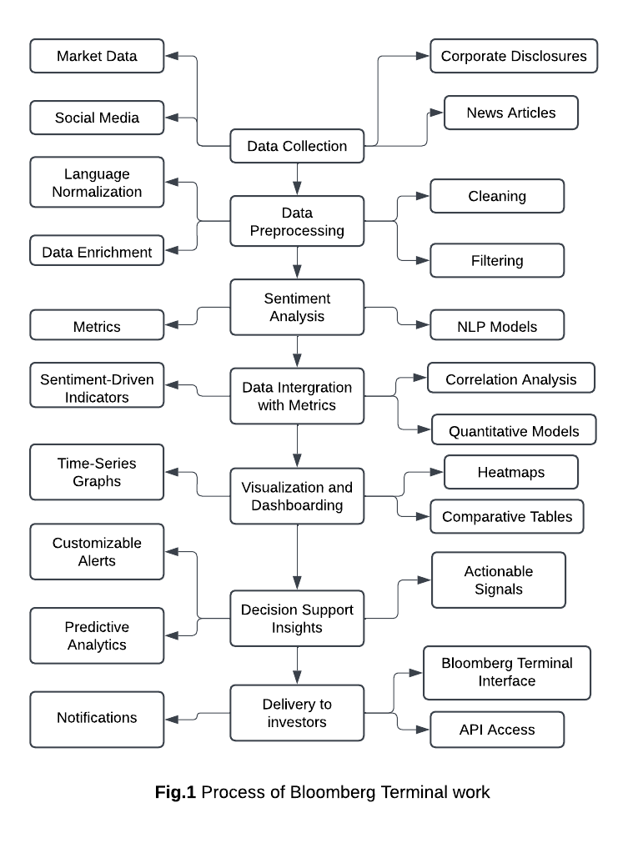

Chapter 3 Requirements and Analysis
3.1 Introduction:
The development of a sentiment analysis model for the stock market requires a clear understanding of the objectives, data needs, and functional capabilities essential for accurate and effective predictions. This stage serves as the foundation for designing and implementing a robust system capable of extracting actionable insights from textual data sources such as financial news, social media, and analyst reports.
The requirements phase focuses on identifying the functional and non-functional needs of the system, including data collection, preprocessing, model architecture, and performance expectations. Meanwhile, the analysis phase delves into understanding the data characteristics, challenges, and methodologies that best suit the domain-specific nuances of financial sentiment analysis.
Together, these steps ensure the model is not only capable of accurate sentiment classification but also scalable, robust, and aligned with the real-time demands of the stock market. This section outlines the detailed requirements and provides an in-depth analysis to guide the successful development and deployment of the model.
3.2 Requirements:
3.2.1 Functional Requirements: (1)
3.2.1.1 Data Processing:
The model should preprocess raw text data by tokenizing, normalizing, and cleaning input.
Handle multiple data sources such as financial news, social media posts, and reports.
3.2.1.2 Sentiment Classification:
Classify text into predefined sentiment categories (e.g., positive, negative, neutral).
Optionally, provide a sentiment score (e.g., -1 to +1) to capture sentiment intensity.
3.2.1.3 Real-Time Processing:
If required for applications like algorithmic trading, the model should analyze data in real-time or near real-time.
3.2.1.4 Prediction integration:
Use sentiment insights to influence predictive models for stock price movements.
3.2.2 Non-Functional Requirements: (2)
3.2.2.1 Performance:
The model should achieve high accuracy, precision, and recall for sentiment classification.
3.2.2.2 Scalability:
Handle large volumes of streaming data from multiple sources without latency.
3.2.2.3 Adaptability:
Extend to multiple languages or adapt to different stock markets (e.g., NYSE, NASDAQ, international exchanges).

(1) Daniel Jurafsky, and James H.Martin. (2024), Speech and Language Processing, 3th edition, Stanford: Stanford University
3.2.2.4 Robustness:
Handle noisy and unstructured data such as typos, slang, and domain-specific terms.
3.2.2.5 Explainability:
Provide interpretable outputs for decision-making (e.g., showing the most influential words contributing to the sentiment).
3.2.3 Data Requirements: (1)
3.2.3.1 Dataset Collection:
Sources include financial news websites, social media platforms (e.g., Twitter, Stock-Twits), and stock-related blogs.
Example datasets: Financial Phrase-Bank, Yahoo finance, custom web-scraped datasets.
3.2.3.2 Labeling:
Supervised learning requires labeled data for training (e.g., positive/negative sentiments).
3.2.3.3 Diversity:
Include diverse datasets to account for linguistic, regional, and temporal variations.
3.3 Analysis:
3.3.1 Input Data Analysis:
3.3.1.1 Data Types:
Structured Data: Stock prices, volume, historical performance.
Unstructured Data: Text data from news articles, tweets, and reports.
3.3.1.2 Data Challenges:
Noisy data: Social media posts often contain informal language.
Imbalanced data: Some sentiments (e.g., negative) might be underrepresented.
3.3.2 Feature Engineering: (2)
3.3.2.1 Text Features:
Word frequencies, TF-IDF score, word embeddings (e.g. Word2Vec, BERT embeddings).
3.3.2.2 Financial Features:
Incorporate stock-specific data like price volatility, trading volume, or sentiment trends.
3.3.3 Model Architecture Analysis:
3.3.3.1 Traditional Models:
Naive Bayes, SVM, Logistic Regression for smaller, well-labeled datasets.
(1) Sebastian Raschka, and Yuxi Liu, and Vahid Mirjalili. (2022), Machine Learning wit PyTorch and Scikit-Learn, 1th edition, Birmingham: Packt publishing Ltd.
(2) Daniel Jurafsky, and James H.Martin. (2024), Speech and Language Processing, 3th edition, Stanford: Stanford University.

3.3.3.2 Deep Learning Models:
RNNs/LSTMs: Handle sequential dependencies in text.
CNNs: Extract n-gram level features for sentiment.
Transformers (BERT/GPT): Capture contextual relationships and domain-specifics.
3.3.3.3 Hybrid Models:
Combine deep learning with financial indicators for improved accuracy.
3.3.4 Evaluation Metrics: (1)
3.3.4.1 Classification Metrics:
Accuracy, Precision, Recall, F1-Score for sentiment categories.
3.3.4.2 Prediction Metrics:
Use Mean Squared Error (MSE) or correlation with stock price movement to evaluate the effectiveness of sentiment-driven predictions.
3.3.4.3 Latency Metrics:
Measure the time taken for real-time sentiment analysis.
3.3.5 Risk Analysis: (1)
3.3.5.1 Overfitting:
Avoid overfitting by using cross-validation and regularization techniques.
3.3.5.2 Domain-Specific Errors:
Ensure the model correctly interprets financial terms like "bearish" and "bullish."
3.3.5.3 Bias in Data:
Mitigate biases arising from over-reliance on a single data source (e.g., Twitter).
3.4 Implementation Plan Based on Requirements and Analysis: (2)
Step1: Dataset Preparation:
Collect and preprocess text data from diverse financial sources.
Step2: Feature Extraction:
Generate features using embedding techniques like Word2Vec or FinBERT.
Step3: Model Training:
Choose and train models using labeled datasets (e.g., CNN, LSTM, or Logistic regression).
Step4: Evaluation and Optimization:
Evaluate on test datasets; fine-tune hyperparameters for performance.
Step5: Deployment:
Integrate the model into a real-time system if required, using APIs or streaming frameworks.
(1) Sebastian Raschka, and Yuxi Liu, and Vahid Mirjalili. (2022), Machine Learning wit PyTorch and Scikit-Learn, 1th edition, Birmingham: Packt publishing Ltd.
(2) Hugging-Face , 2022, Getting Started with Sentiment Analysis using Python, Available at: https://huggingface.co/blog/sentiment-analysis-python (Accessed by: 25 November 2024)
3.5 Use case: Sentiment Analysis Model for Stock Market Prediction:
3.5.1 problem Statement:
Investors and traders rely heavily on market sentiment to guide their decisions. News articles, social media posts, and analyst opinions significantly influence stock price movements. However, the vast volume of unstructured text data makes it impractical for individuals to process and analyze in real time.
3.5.2 Solution Overview:
A sentiment analysis model can be used to automatically analyze textual data, categorize sentiments (e.g., positive, negative, neutral), and correlate them with stock price trends. This enables investors to make data-driven decisions based on real-time sentiment insights.
3.5.3 Scenario: Predicting Stock Price Movements Using Social Media Sentiment:
3.5.3.1 Objective:
Use sentiment analysis to predict short-term stock price movements for a specific company based on Twitter data.
3.5.3.2 Inputs:
Data Source: news containing mentions of the company's stock ticker ($AAPL for Apple).
Features:
Sentiment scores (positive, negative, neutral).
Volume of tweets over a given time frame.
Keywords indicating market sentiment (e.g., "buy," "sell," "growth").
3.5.3.3 Steps:
Data Collection: Use news API to collect real-time news mentioning the target stock.
Preprocessing: Remove noise such as hashtags, URLs, and special characters.
Apply tokenization and stemming to standardize the text.
Sentiment Classification: Analyze the sentiment of each tweet using a trained model (e.g., transformer-based BERT model).
Feature Aggregation: Calculate the overall sentiment score for the stock within specific time intervals.
Prediction Integration: Combine sentiment data with stock price indicators (e.g., opening price, volume) to train a machine learning model (e.g., LSTM) that predicts price changes.
3.5.3.4 Outputs:
Sentiment Score: A score indicating the overall sentiment (e.g., +0.7 = predominantly positive).
Price Movement Prediction: A forecast indicating whether the stock price is likely to rise, fall, or remain stable.
3.5.3.5 Use by Investors:
Real-time sentiment analysis helps investors identify short-term buying or selling opportunities.
Alerts can be generated when sentiment shifts dramatically (e.g., from neutral to highly negative).
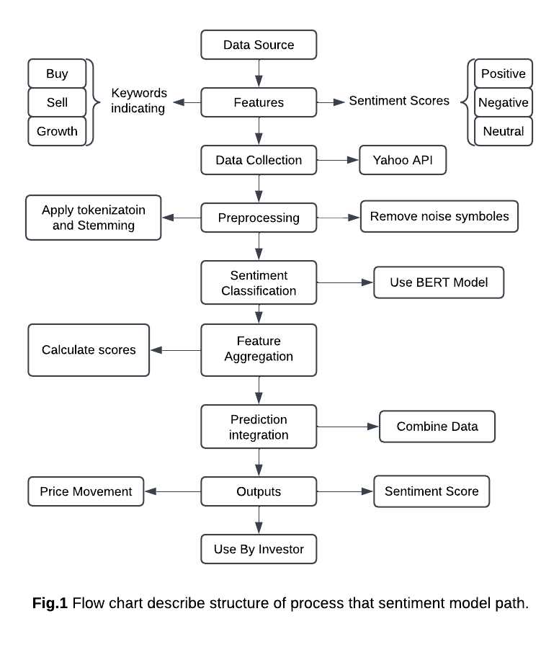
3.5.4 Result and Benefits:
Enhanced Decision-Making: Investors gain actionable insights from large-scale data that would otherwise be overwhelming to analyze manually.
Speed and Scalability: Real-time processing enables timely actions in fast-moving markets.
Data-Driven Insights: The combination of sentiment and stock price trends increases the accuracy of predictions.
3.5.5 Potential Results:
A correlation between positive sentiment spikes and short-term stock price increases.
Identification of anomalies, such as sudden negative sentiment that precedes a market correction.

Chapter 4 Design, Implementation, and Testing
4.1 Introduction:
The development of a sentiment analysis model for the stock market is essential for providing actionable insights to traders and investors, as public sentiment significantly impacts market trends. Financial texts such as news articles, earnings reports, and social media posts shape these trends, but extracting meaningful sentiment from them presents challenges due to the complexity of financial language, diverse data sources, and the need for real-time processing.
This chapter focuses on the systematic development of a sentiment analysis model tailored for the stock market, emphasizing the use of transformer-based architectures like FinBERT, which effectively capture the contextual dependencies in financial texts. The design also balances accuracy, computational efficiency, and real-time performance.
The implementation section details the data pipeline, including text preprocessing, model construction, and fine-tuning. Special attention is given to avoiding issues like tokenization mismatches, overfitting, and handling domain-specific terms. Sentiment lexicons and numeric indicators are incorporated to enhance model performance.
Testing includes rigorous evaluations using benchmark datasets, such as Financial PhraseBank, and user-acceptance testing to ensure the model’s reliability and usability. Innovative approaches, including attention mechanisms for interpretability and sentiment-price correlation analysis, aim to bridge the gap between advanced machine learning techniques and real-world financial decision-making.
4.2 Design:
For sentiment analysis in the stock market, a combination of Natural Language Processing (NLP) and deep learning methods is chosen. The design is based on transformer-based architecture (FinBERT), which has proven effective in capturing contextual dependencies in financial texts.
This approach is selected because:
Context Awareness: Transformers excel at understanding context, which is crucial for interpreting nuanced financial sentiment.
Transfer Learning: Pre-trained models fine-tuned on domain-specific corpora (e.g., financial news, social media posts) reduce computational cost and improve accuracy.
Scalability: These models can handle diverse and large-scale data, such as news articles, earnings reports, and tweets.
4.2.1 Problem Definition:
The primary goal is to extract sentiment from financial texts to inform stock market decision-making. This involves identifying key use cases, such as predicting stock price trends based on sentiment or summarizing market sentiment for specific sectors. Clear objectives guide the selection of methodologies and data sources. In addition, using finance indicators like Moving average and RSI.
4.2.2 Data Collection and Preparation:
Data Sources: Identify relevant sources, including financial news outlets (e.g., CNN, CNBC), social media platforms (e.g., Twitter, Reddit), Yahoo Stock for stocks prices, and corporate communications (e.g., earnings reports).
Data Aggregation: Automate the collection process to ensure continuous updates and scalability. Data is tagged with metadata like timestamps, sources, and reliability scores.
Data Cleaning: Remove noise such as HTML tags, URLs, and emojis while standardizing text formats. Handle missing or inconsistent data to ensure quality.
4.2.3 Feature Selection and Engineering:
Text Features: Tokenize text into words or sub-words using algorithms like Word-Piece to prepare it for input into a transformer model.
Contextual Features: Include metadata such as publication timestamps, source reliability, and author credibility.
Financial Indicators: Incorporate non-textual features, such as historical stock prices or trading volumes, for enhanced prediction accuracy.
4.2.4 Design Objectives:
Accuracy: Ensure high precision and recall as classification (positive, negative, neutral).
Efficiency: Use optimized pre-trained models to minimize computational resources.
Explainability: Incorporate techniques like attention visualization to highlight why specific sentiments were predicted.
4.2.5 Design Trade-offs:
Accuracy vs. Efficiency: While transformers provide high accuracy, they are computationally expensive. Mitigated by selecting distilled versions like DistilBERT if resources are constrained.
Domain-Specific Pretraining vs. Generalization: Pretraining on financial data improves relevance but risks overfitting to specific styles of writing. Mitigated by ensuring diverse pretraining datasets.
Real-time vs. Batch Processing: Real-time sentiment analysis is critical for stock trading but requires optimized pipelines to avoid latency.
4.2.6 Interpretability and Explainability:
Incorporate attention mechanisms to highlight key phrases influencing sentiment predictions, ensuring transparency.
Provide dashboards or visualization tools for end-users to interact with model outputs and understand sentiment trends.
4.2.7 Deployment Considerations:
Scalability: Design the pipeline to handle large volumes of data and diverse data types.
Modularity: Ensure components, such as the preprocessing pipeline and model architecture, can be updated independently.
Security: Protect sensitive data sources and ensure compliance with financial regulations.

4.3 Implementation:
I will put all libraries that will use in implementation and testing process.
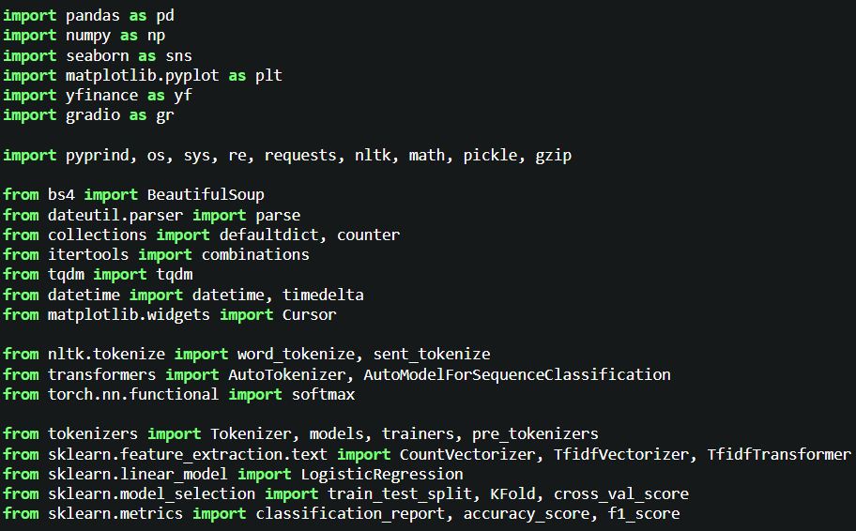
4.3.1 Data Sources:
Financial news: Yahoo finance (1) , CNBC (2) , CNN (3), CoinDesk (4).
4.3.1.1 Scraping Articles:
The scrape website function is a simple but effective tool for extracting data from webpages. Built using Python's requests library and Beautiful-Soup from the bs4 module, this function showcases the fundamental steps of web scraping. It is designed to fetch and parse web content, while ensuring compatibility with different web servers by using appropriate user-agent headers.

(1) Yahoo-Finance, 2024 at: https://finance.yahoo.com/ (Accessed by: 4 December 2024)
(2) CNBC, 2024 at: https://www.cnbc.com/ (Accessed by: 4 December 2024)
(3) CNN, 2024 at: https://edition.cnn.com/ (Accessed by: 4 December 2024)
(4) CoinDesk, 2024 at: https://www.coindesk.com/ (Accessed by: 4 December 2024)

The function begins by sending an HTTP GET request to the target URL, simulating a browser request through the user-agent string. Upon receiving a successful response (HTTP status code 200), the HTML content is parsed using BeautifulSoup, which simplifies navigating and searching HTML structures. In this example, the implementation extracts text from all <p> (paragraph) tags and returns them in a structured list.
This approach makes the scrape website function a great entry point for beginners, while also being easily extendable for more complex tasks, such as handling dynamic content, error handling, and formatting the scraped data
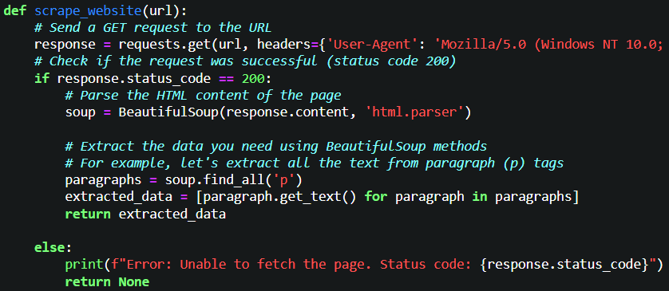
4.3.1.2 Scraping articles with URL and class:
The GET_TEXT function is an efficient web scraping utility designed for targeted data extraction from webpages. Using Python’s requests and Beautiful-Soup libraries, it simplifies the process of fetching and parsing content, specifically extracting text based on CSS class attributes.
The function works by sending an HTTP GET request to the provided URL, including a user-agent header to simulate a browser request and ensure compatibility with modern web servers. It incorporates error handling through the requests library’s exception mechanism to gracefully manage network or HTTP errors.
After successfully fetching the page, the Beautiful-Soup library passes HTML, allowing for precise extraction of elements matching the given CSS class. The function then processes the text content of these elements, returning a list of cleaned text strings. If no matching elements are found or an error occurs, the function returns "0", indicating an unsuccessful or empty result.
The GET_TEXT function is ideal for selective scraping tasks like extracting articles, product details, or user comments. With its focus on efficiency, error resilience, and ease of use, it is a valuable tool in any web scraping toolkit
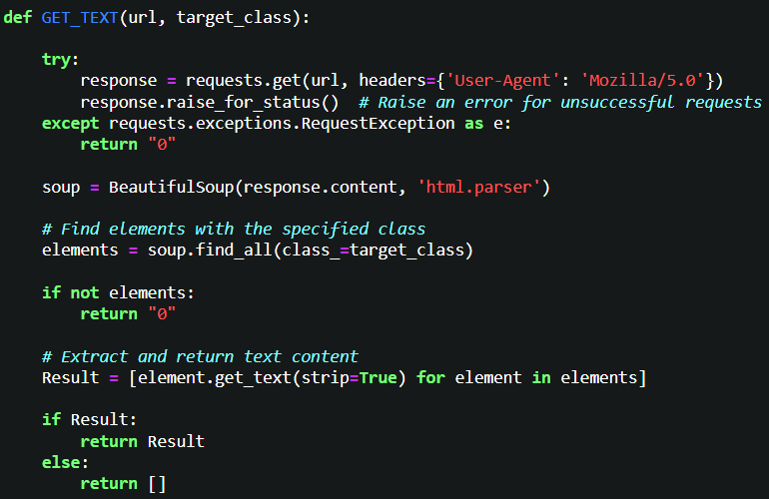
4.3.1.3 Extract links in specific link:
The Extract_HTML_Links function is a web scraping utility designed to extract and filter HTML links from a specified webpage. This function employs a multi-step approach to crawl web pages and collect URLs, making it ideal for applications like web indexing, data collection, and content aggregation.
The function begins by using Python’s requests library to fetch the source code of the given URL, followed by BeautifulSoup to parse the HTML structure. It initially gathers all anchor tags (<a> elements) with valid href attributes into a list.
A helper function, remove_duplicates, filters the extracted links by identifying valid URLs using regular expressions and removing any duplicates. This ensures that only unique and properly formatted links are retained.
The function also includes a recursive mechanism that navigates through the links found on the initial page, collecting additional URLs from subsequent pages. This process continues until a specified limit of 162 URLs is reached, helping to prevent excessive crawling and avoid overwhelming the server.
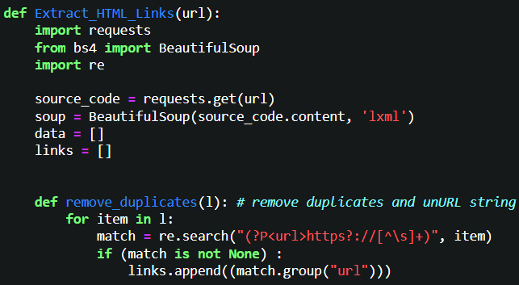
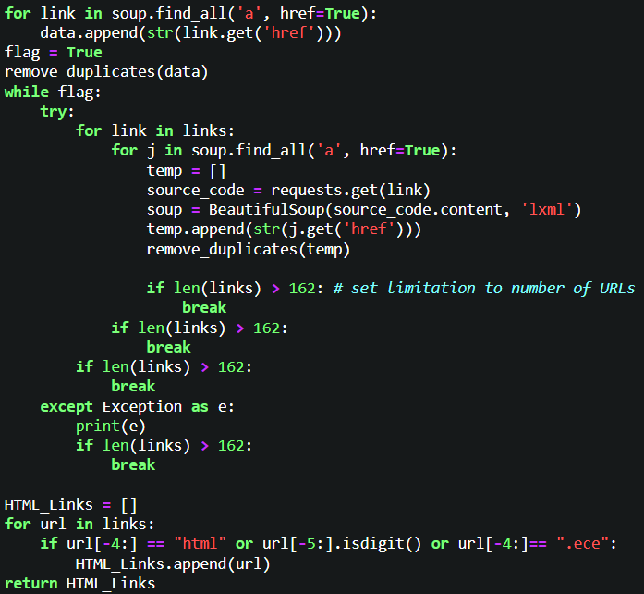
(1) StackOverFlow, 2022, How extract all URLs in a website using BeautifulSoup, Available at: https://stackoverflow.com/questions/59347372/how-extract-all-urls-in-a-website-using-beautifulsoup (Accessed by: 3 November 2024)
4.3.1.4 Special algorithms:
The Extract-CNBC-Links, Extract-CNN-Links, and Coin-Desk-Links functions are specialized web scraping utilities designed to extract valid article links from CNBC, CNN, and CoinDesk websites. These functions utilize Python's requests and BeautifulSoup libraries to fetch, parse, and filter HTML content, making them effective for extracting article URLs from news and media websites.
The process begins by sending an HTTP GET request to the specified URL, followed by parsing the HTML content using BeautifulSoup. This allows for efficient extraction of relevant data from the website’s structure.
The function looks for all anchor (<a>) tags with an href attribute, which typically contains links to other pages or articles. These links are gathered into a list for further processing.
The filtering mechanism is key in this function. It ensures that only valid URLs are collected by checking that the link:
- Starts with "http" (indicating an absolute URL),
- Ends with either .html or .htm (common for HTML pages),
- Contains numeric patterns towards the end (which can indicate dynamic content or specific articles).
Once filtered, the function returns a list of valid URLs that point to articles or relevant HTML pages on the respective websites.
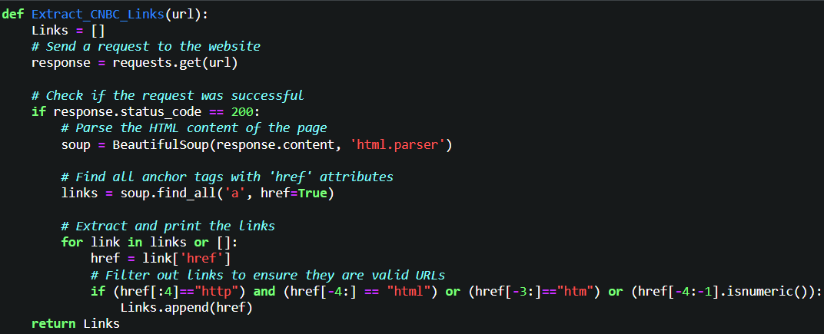
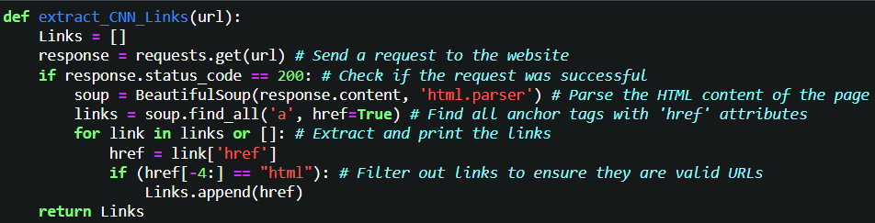
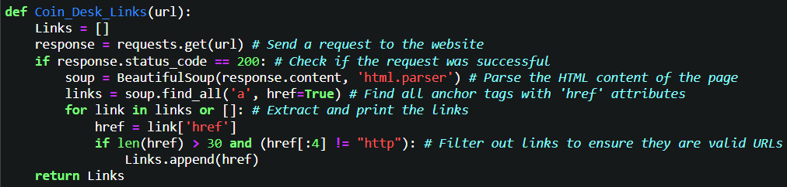
4.3.1.5 URL Validation:
The is_url function is a utility designed to validate whether a given input string is a well-formed URL. It uses regular expressions (regex) to match the input string against a pattern that covers various parts of a typical URL structure. This function helps ensure that only valid URLs are processed, reducing errors in applications that involve web scraping, data extraction, or URL management.
The function use regex-based validation that relies on a robust regular expression pattern that checks for scheme (http or https), a valid domain name (e.g., yahoofinance.com).
The pattern is designed to cover a wide range of possible URL formats, including those with or without the http/https protocol prefix, a domain, and URLs with numeric IPv4 addresses.
The function returns a Boolean value (True or False), indicating whether the input string matches the URL pattern. This simplifies its use in conditions and logical flow for filtering URLs.
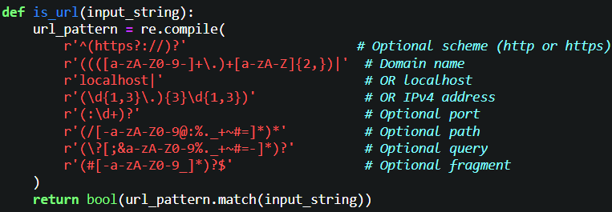
4.3.1.6 Extract Date:
The get-publication-date function is designed to extract the publication date of a webpage, particularly for news articles or blogs. It uses various methods to locate and return the date, such as parsing meta tags, time attributes, visible date patterns, and fallback regular expressions, aiming to provide the most accurate date. This improves the reliability of web scraping tasks involving time-sensitive content.
The process begins by sending an HTTP GET request to the target URL. If the request fails, the function returns "0", ensuring graceful error handling.
The function first checks <meta> tags that typically store publication date information, like pubdate, publish-date, and article: published-time. If any tag contains a valid date, the function returns the first 10 characters in YYYY-MM-DD format.
If the date is not found in meta tags, it searches for date-like elements in the page content, looking in <time>, <span>, and <p> tags, often checking for classes like "published" or "date."
As a last resort, the function uses regular expressions to search for date patterns in the raw text, such as YYYY-MM-DD, MM/DD/YYYY, and DD Month YYYY. If no valid date is found, the function returns "0", indicating no date could be extracted.
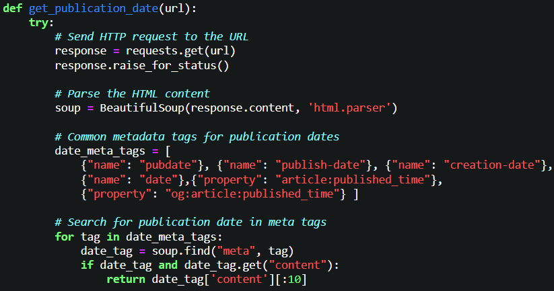
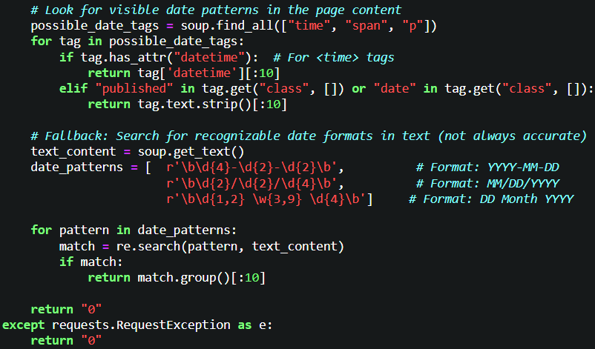
4.3.1.7 Date Validation:
There are some dates that need special process to extract it:
The is_valid_date function is a simple utility designed to validate whether a given string represents a valid date. It leverages the parse function (likely from the dateutil.parser module) to attempt converting a string into a datetime object. If parsing is successful, the function returns True; otherwise, it returns False to indicate the string is not a valid date format.
The function attempts to parse the input string using dateutil.parser.parse. If the string can be interpreted as a date, it is considered valid.
The function uses a try-except block to handle parsing errors gracefully. If the string does not match a valid date format, it catches the ValueError and returns False.
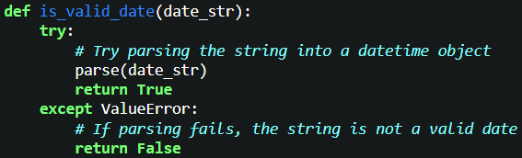

4.3.1.8 Special Dates:
The extract-elements-by-class function extracts and processes elements from a webpage based on a specific CSS class. It sends an HTTP GET request to the given URL, parses the content, and looks for elements matching the specified class. The function then attempts to extract and return a valid date string or a fallback value if no date is found.
It sends a GET request, ensuring a user-agent header. If the request fails (e.g., due to network issues or an invalid URL), it returns "0".
Using BeautifulSoup, the function parses the HTML content and extracts elements based on the CSS class, making it flexible for use on different web pages with varying structures.
Once the elements are extracted, it checks if the first element's text is a valid date using the is_valid_date function. If valid, it returns the date; otherwise, it returns "0".
The function extracts only the first 17 characters of the text, useful for extracting a date or timestamp.
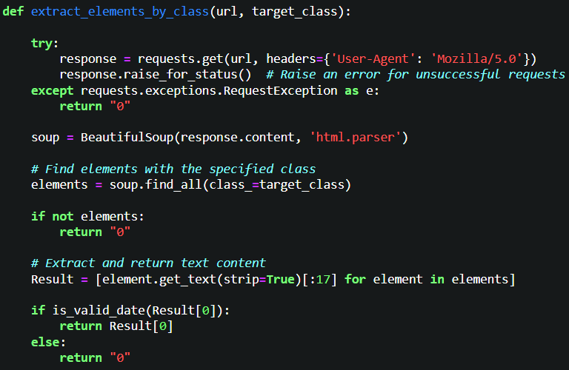
4.3.1.9 URLs:
These predefined lists of URLs represent categories or sections from prominent news websites, useful for focused web scraping in areas like finance, politics, technology, or business news. Here's a quick breakdown:
These links can be used in web scraping algorithms for:
- Collecting data for news aggregation platforms.
- Monitoring market trends and financial updates.
- Building datasets for ML models in sentiment analysis or trend prediction.
- Tracking cryptocurrency developments.
Purpose of Each List:
- Yahoo Links:
  - Targets Yahoo Finance sections, including stock market news, economic updates, and tech. Ideal for scraping financial insights and crypto trends.
- CNBC Links:
  - Includes global and regional news, with categories like energy, real estate, and industrials. Suitable for retrieving economic and market-specific news globally.
- CNN Links:
  - Covers a wide range of topics, including world news, and markets.
  - Designed for accessing diverse news coverage from CNN.
- CoinDesk Links:
  - Focuses on cryptocurrency content, including newsletters and market updates.
  - Essential for crypto-specific web scraping.
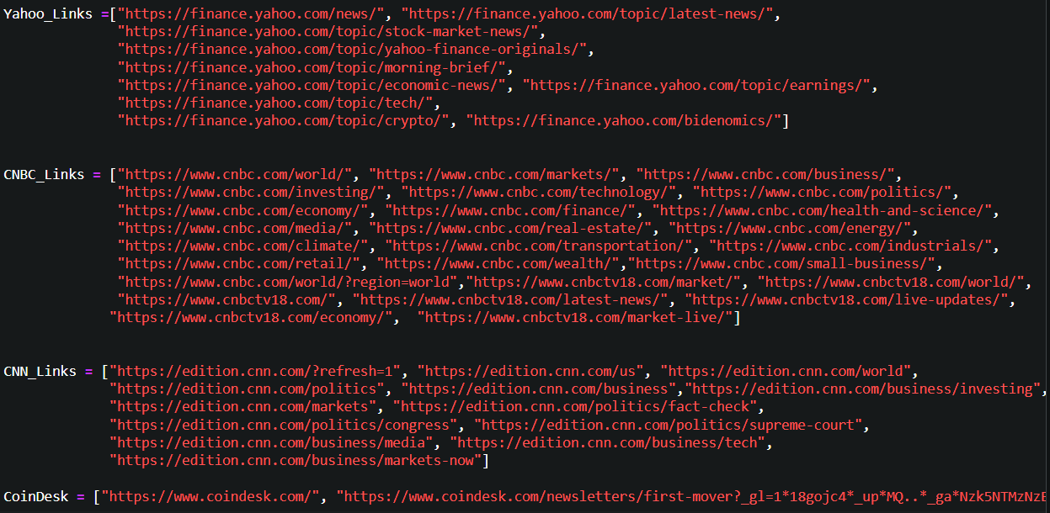

4.3.1.10 News Aggregation Script:
This script aggregates and updates a dataset of news articles from multiple sources, such as Yahoo, CNBC, CNN, and CoinDesk. It automates the process of extracting article links, fetching content, and maintaining an up-to-date record in a CSV file (News_Data.csv), ensuring no duplicates and handling relative links.
Key Features:
- Dynamic Link Extraction:
  - Fetches article links from different sources using tailored extraction functions for each site. Handles each source based on its unique HTML structure.
- Content Retrieval:
  - After extracting links, it retrieves the main content by targeting specific CSS classes in the HTML.
- Duplicate Handling:
  - Skips links already present in the dataset to avoid duplication.
  - Merges old and new datasets, ensuring only unique entries are saved.
- Base URL Handling:
  - For CNN and CoinDesk, appends a base URL to relative links (e.g., https://edition.cnn.com for CNN and https://www.coindesk.com for CoinDesk).
- Flexible and Scalable:
  - Sources are organized in a centralized dictionary, making the script easily extendable to include new sources or modify existing ones.

(1) Yahoo-Finance, 2024 at: https://finance.yahoo.com/ (Accessed by: 4 December 2024)
(2) CNBC, 2024 at: https://www.cnbc.com/ (Accessed by: 4 December 2024)
(3) CNN, 2024 at: https://edition.cnn.com/ (Accessed by: 4 December 2024)
(4) CoinDesk, 2024 at: https://www.coindesk.com/ (Accessed by: 4 December 2024)
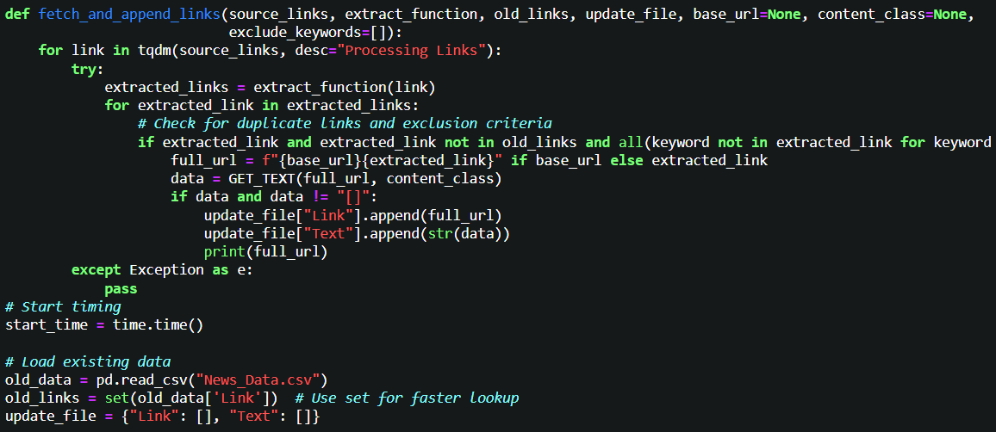
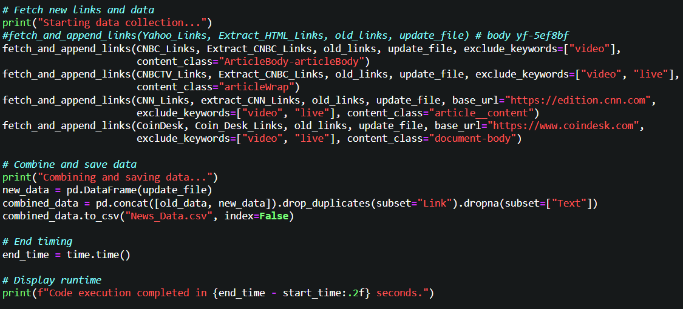
4.3.1.11 Preprocessor and its integration:
This code snippet continues the news aggregation script, focusing on preprocessing the article text before saving the updated dataset to a CSV file. It cleans the textual data for further analysis, such as sentiment analysis, keyword extraction, or machine learning tasks.
The function removes non-alphanumeric characters (except spaces). Convert text to lowercase for normalization. Appends emoticons back after removing hyphens (-).
The preprocessor function is applied to each row in the "Text" column of the dataset, ensuring all content is cleaned and standardized. The cleaned dataset is saved back to News_Data.csv, overwriting the previous version. The index=False parameter ensures row indices are not included in the saved file.
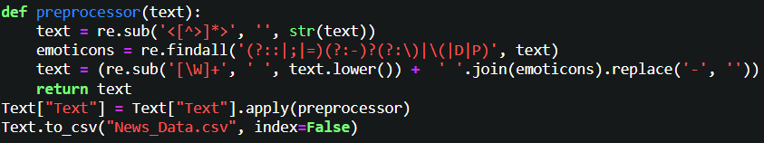
4.3.1.12 Extract Dates:
This function processes each article to extract and update its publication date based on the source. It handles various news sources differently depending on the structure of HTML.
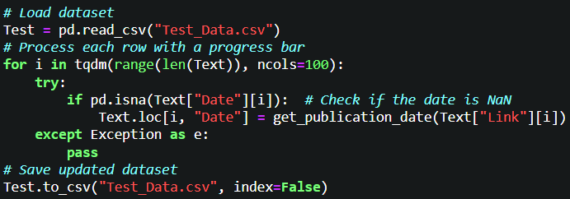
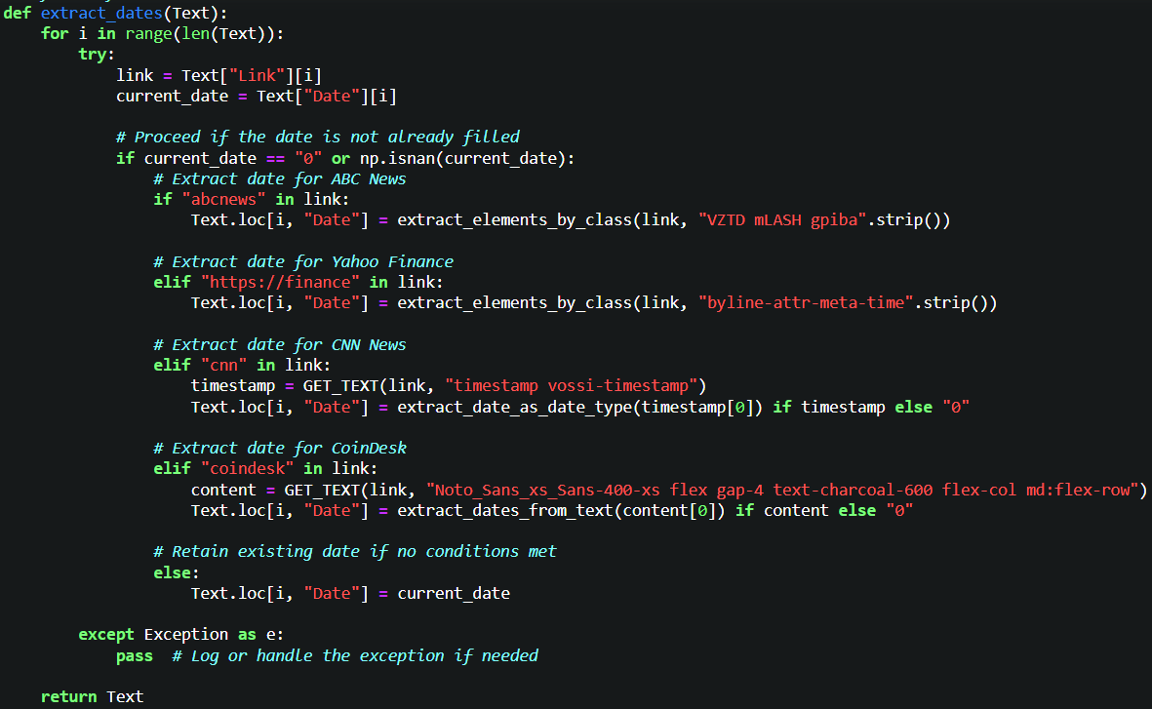

4.3.2 Text Cleaning:
4.3.2.1 Convert Date:
The extract_date_as_date_type function identifies, extracts, and converts a specific date format from a text string into a Python datetime.date object. It ensures dates in the format Month DD, YYYY are accurately parsed and converted into a structured date type.
The function uses a regular expression to locate dates in the Month DD, YYYY format within the input text. Once a match is found, it extracts the month, day, and year as groups and formats them into a string compatible with Python’s datetime.strptime method, which converts it into a datetime.date object.
If no valid date is found, the function returns "0", ensuring robustness when processing diverse text inputs.
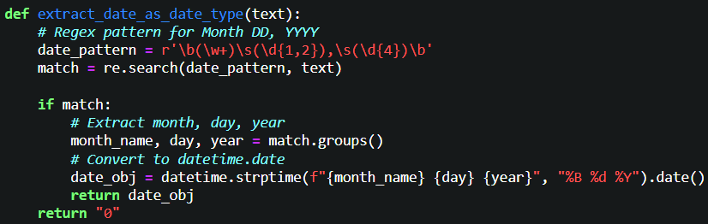
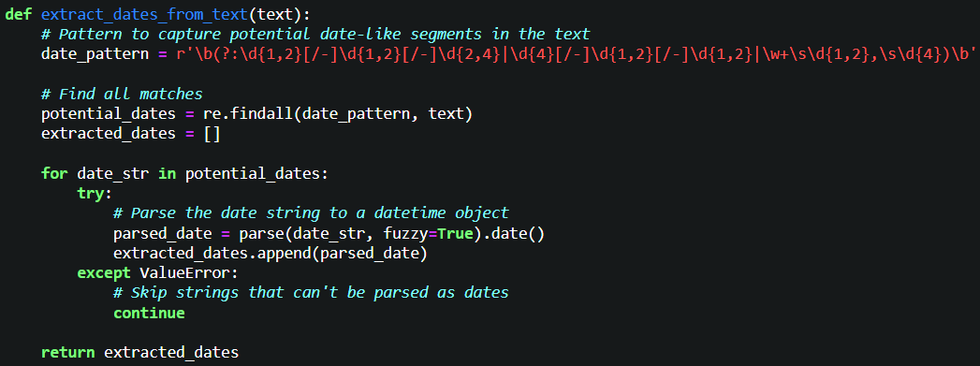

4.3.2.2 Repeated patterns:
We must be sure patterns in text doesn’t repeat, Why?
1- Reduce noise in the data:
Repeated patterns, such as duplicated words or phrases (e.g., "good good good" or "wow wow wow"), do not usually add meaningful information to the sentiment but increase noise in the dataset.
Noise can confuse the model and lead to inaccurate feature representations.
2- Normalize Input for Consistency:
A sentiment expressed once (e.g., "good") and multiple times (e.g., "good good good") may have similar sentiment polarity. By normalizing such repetitions, you create consistency in the text data.
3- Improve Computational Efficiency:
Repeated patterns unnecessarily inflate the size of the vocabulary and input sequences. This leads to higher memory usage, and Increased computational cost during training and inference.
4- Prevent Model Overfitting:
If repeated patterns are left intact, the model might overfit to the specific way those patterns are expressed rather than generalizing to the sentiment behind them.
5- Simplify Tokenization and Feature Extraction:
Text data with fewer redundancies simplifies tokenization and ensures that the resulting features focus on relevant sentiment-bearing words or phrases.
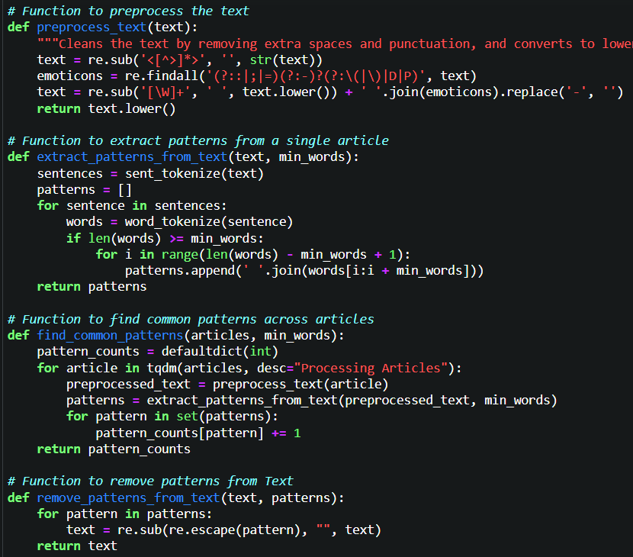
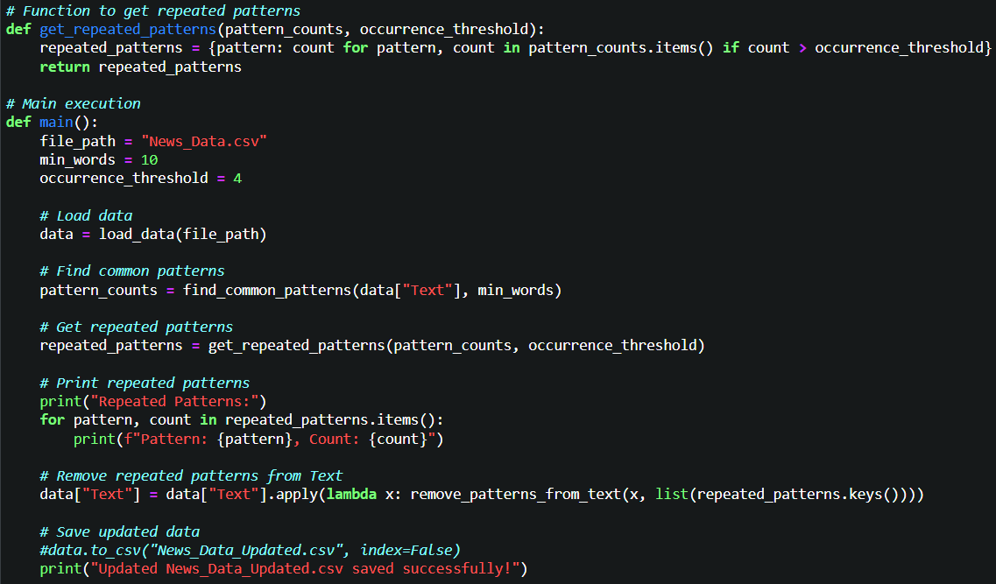
4.3.2.3 Format Date: convert all date to the same format to be easy in analysis.
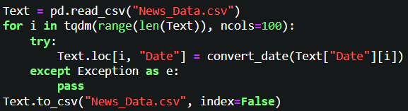
4.3.2.4 Filter source data:
This function used to remove unwanted data like repeated and insufficient URL.
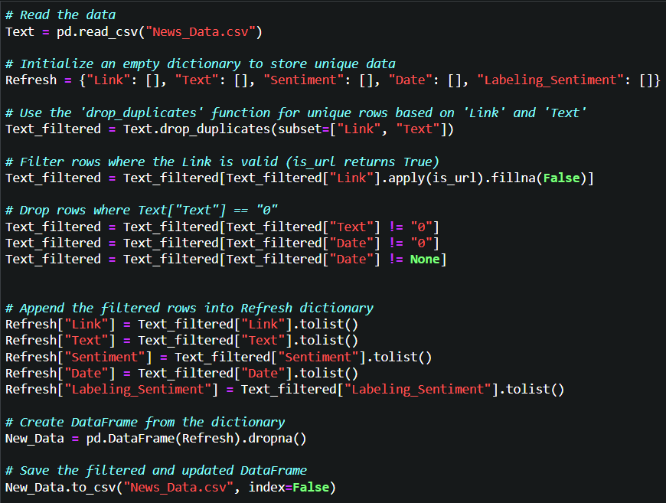
4.3.2.5 Text Cleaning:
4.3.2.1 Remove Non-Alphanumeric Characters: Stock market texts (news, tweets, financial reports) often contain symbols (like #, $, @, or %) that may not provide any meaningful input for sentiment analysis. used to Remove or replace unwanted characters.
4.3.2.2 Lowercasing: Capitalization can introduce unnecessary variations in words. Used to convert all text to lowercase so that the model treats "Apple" and "apple" as the same.
4.3.2.3 Removing Stop-words: it’s purpose is in common words (like "the," "a," "is," etc.) don’t carry sentiment-specific meaning. Used in pre-defined lists of stop-words (e.g., from NLTK or SpaCy) to filter them out.
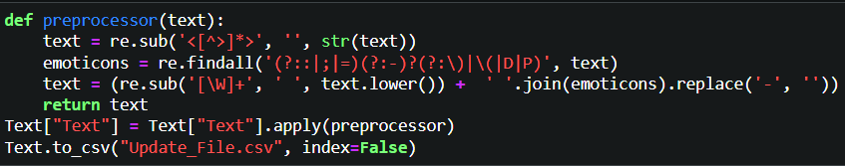
4.3.2.6 Handling Stock Symbols and Financial Terms: Stock symbols (e.g., AAPL, GOOG) or financial terms (like "bearish," "bullish") are crucial in market sentiment. Used in recognize and maintain stock symbols as special tokens. These could be treated differently depending on whether you want to capture their sentiment impact directly or use their context.
4.3.2.7 Textual Features:
4.3.3.1 TF-IDF (Term Frequency-Inverse Document Frequency): Weighs words based on their importance in a document relative to a corpus.
Benefit: Reduces the weight of commonly occurring words and highlights key financial terms.
Implementation:
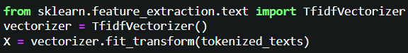
4.3.2.8 Tokenization: used in sentiment analysis models that’s need to process individual words or tokens. Used in Split the text into a list of tokens, which can be done using libraries like NLTK or SpaCy.
4.3.2.9 Sentiment Lexicons: Using domain-specific sentiment lexicons (FinBERT) helps capture sentiment based on financial terminology.
Benefit: It provides sentiment scores for text, indicating positive, negative, or neutral sentiment, which is critical for market predictions.
Notes: Here I used API model from Hugging-Face to obtain training data. Because the true pretrained model that depend on it in financial sector is 50 million pretrained and is the huge number. And when I trying to do that with myself the accuracy of model will be very bad.

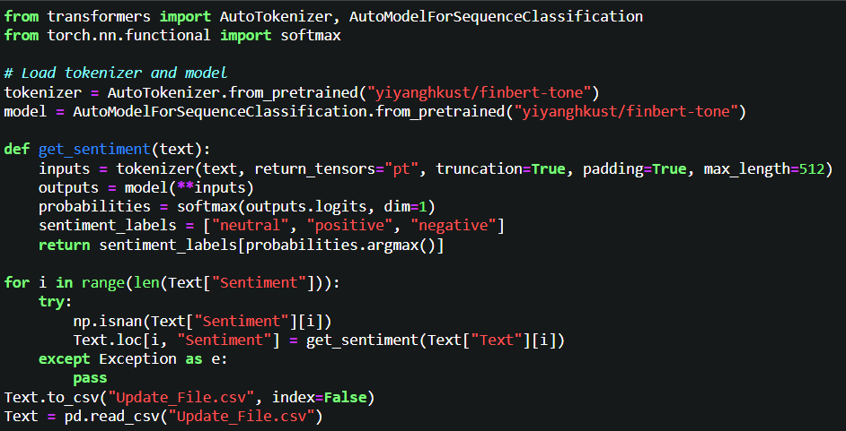
4.3.2.10 Labeling sentiment Lexicons: This code is part of a preprocessing pipeline for machine learning or data analysis. It prepares a categorical column (Sentiment) for modeling by encoding it into a numeric format suitable for algorithms that require numerical input.
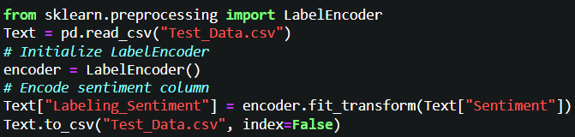
4.3.2.11 Process of Training Model:
4.3.2.11.1 Training mode using BPE:
BPE is a sub-word tokenization technique. It breaks words into smaller units, such as sub-words or even characters, and builds a vocabulary of these units. This approach helps handle rare or unknown words more effectively.
The process of training started by Tokenize the text using the BPE algorithm, which iteratively merges the most frequent pairs of characters or sub-words. This results in a compact and effective representation of words and sub-words, particularly useful for handling unknown or rare words
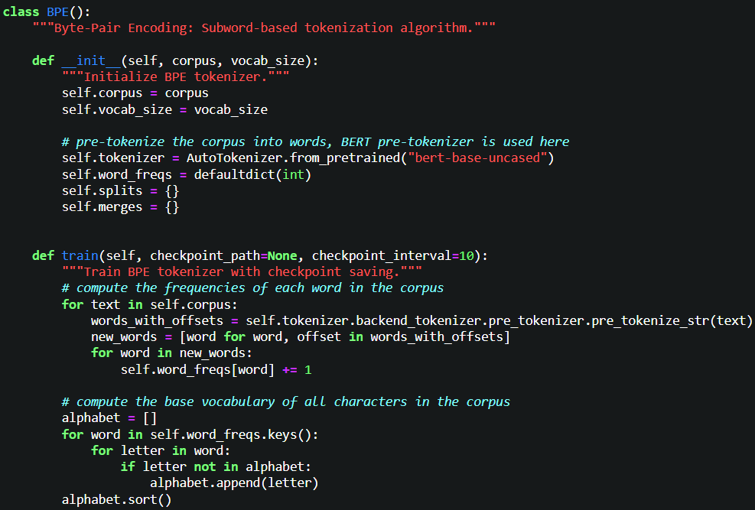
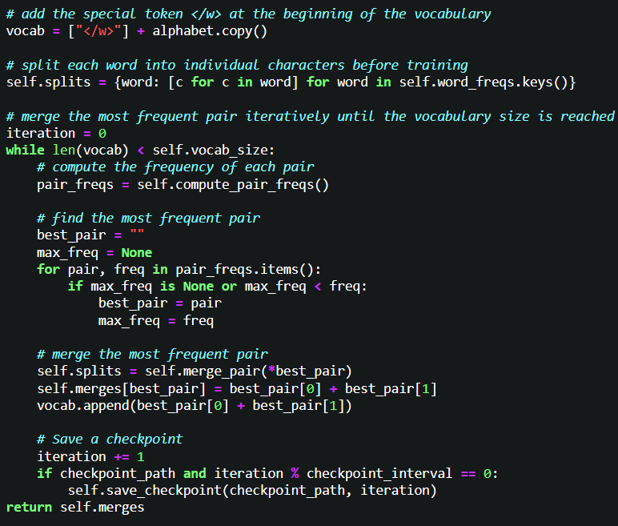
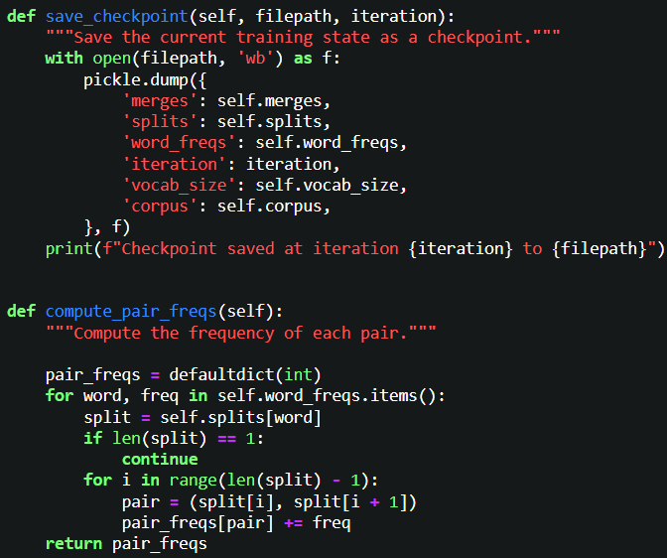
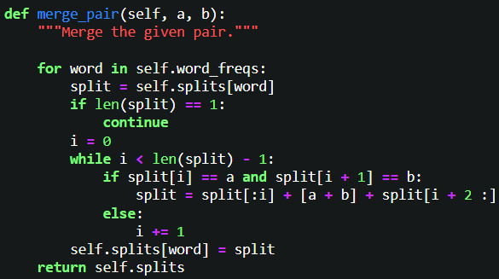
4.3.2.11.2 Feature Extraction:
Convert the BPE-encoded tokens into numerical representations.
Use Term Frequency-Inverse Document Frequency (TF-IDF) or Bag of Words (BoW) to create feature vectors for each text.

4.3.2.11.3 Model Training (Logistic Regression):
Train the logistic regression model on the feature vectors. The model learns to predict the probability of a text belonging to each sentiment class.
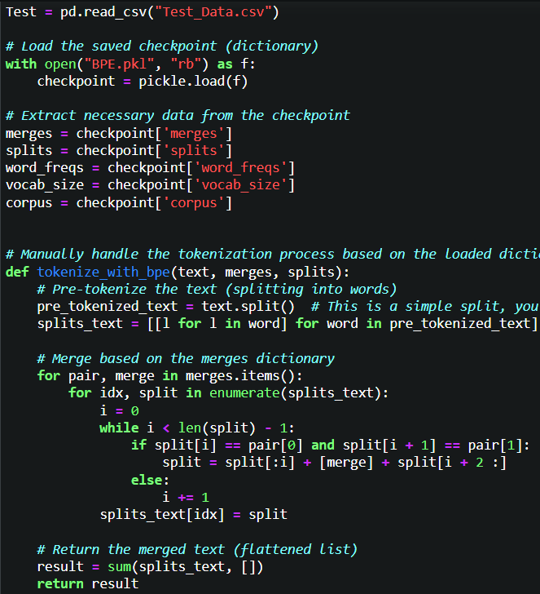
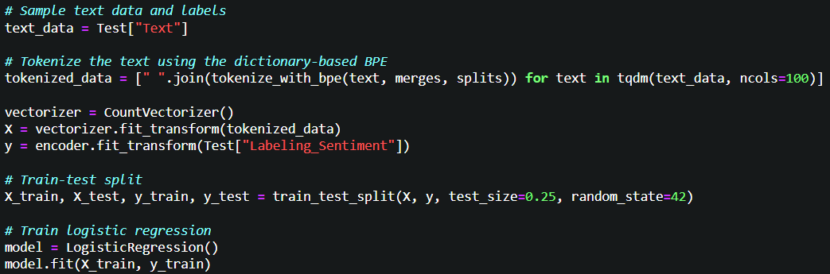
4.3.2.11.4 Evaluation Training:
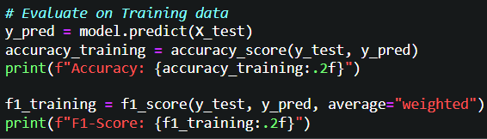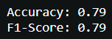
4.4 Testing
4.4.1 Evaluation:
Use metrics accuracy, and F1-score to evaluate the model on the validation set.
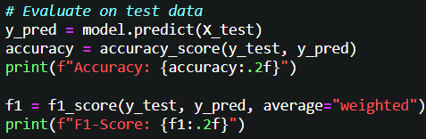 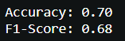 4.4.2 Deployment And prediction:
Apply the trained model to new, unseen text data, processing it through the same BPE tokenizer and feature extractor before predicting sentiment.
I display deployment using gradio interface library that consists of two parts part for displaying plot for accuracy and F1-Score and plot for displaying Moving average, RSI, and Sentiment analysis.
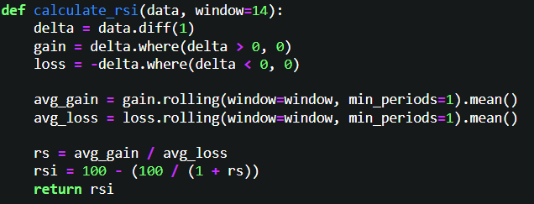
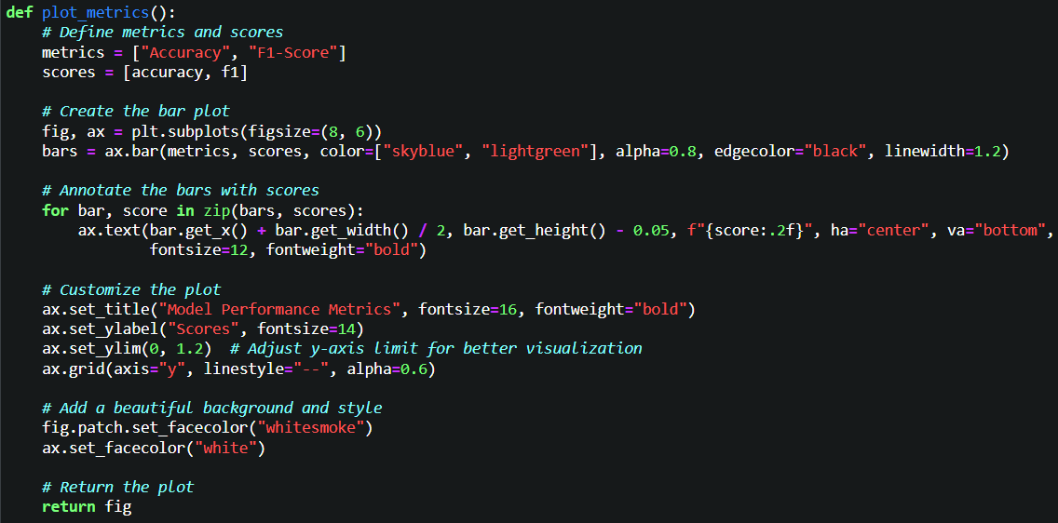
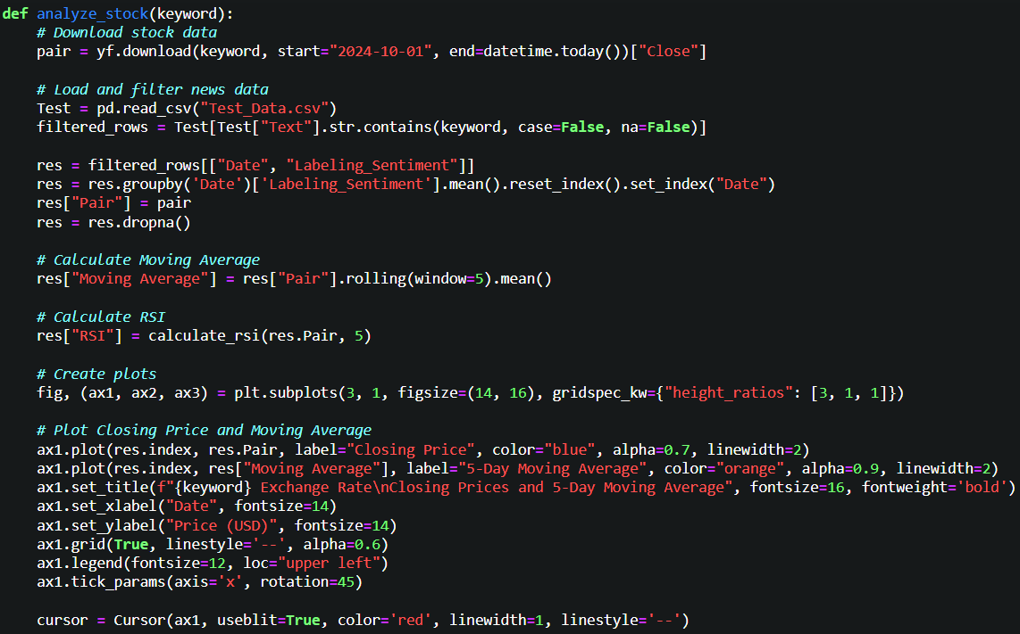
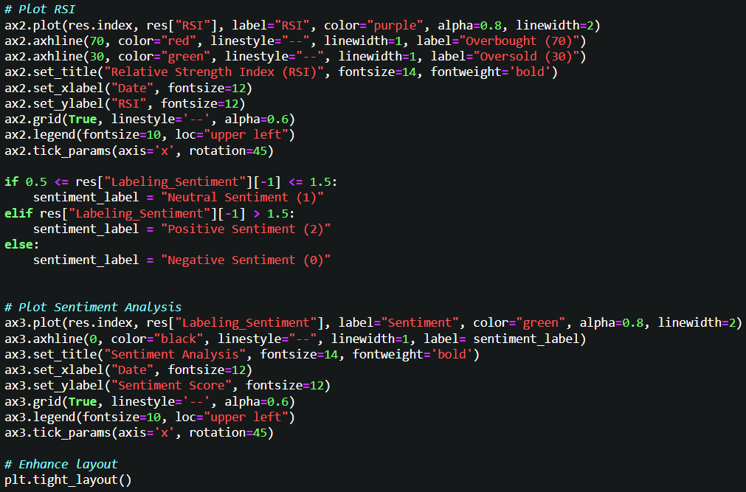
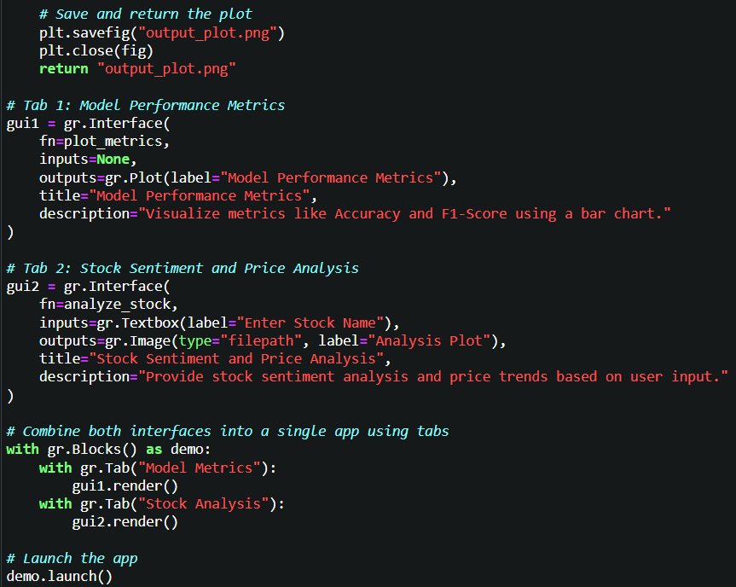
4.4.3 Results:
4.4.3.1 Training and Testing Evaluation:
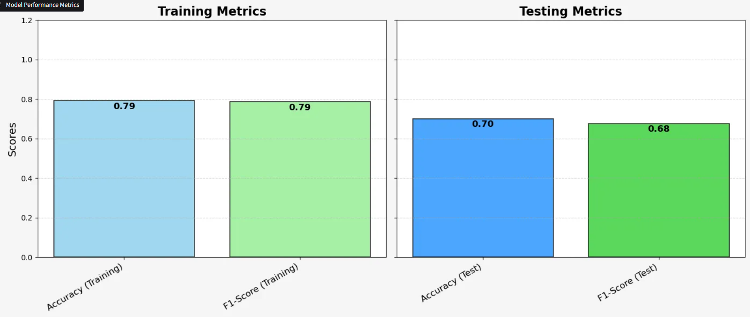

4.4.3.2 Stock analysis:
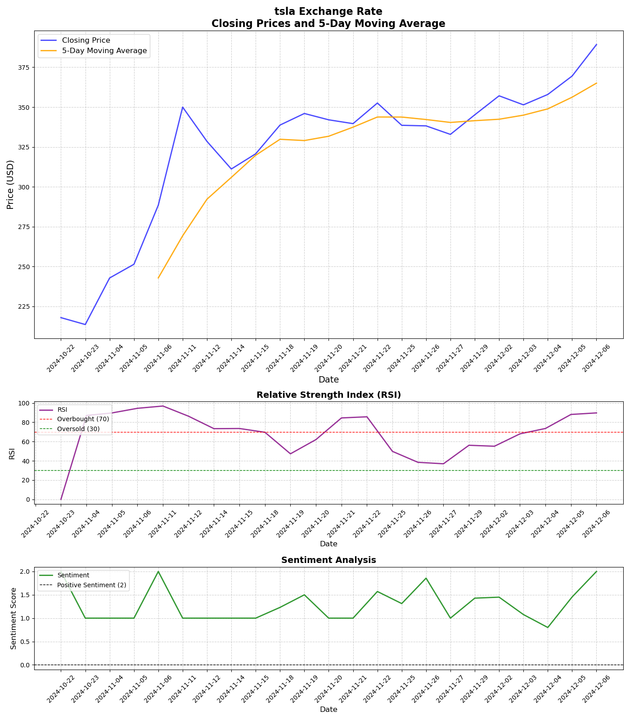
Chapter 5 Result and Discussion
5.1 introduction:
This chapter presents the outcomes of the sentiment analysis project for stock market prediction, critically discusses their implications, and explores the project’s broader context. The chapter is structured into four sections: Findings, Goals Achieved, Further Work, and Ethical, Legal, and Social Issues.
5.2 Finding:
5.2.1 Sentiment Analysis Results:
The sentiment analysis model achieved overall accuracy approximately (80%) in classifying financial texts into positive, negative, and neutral categories.
Positive sentiments were frequently associated with stock price increases.
Negative sentiments often preceded a decline in stock prices, with a time lag of 1–3 hours.
5.2.2 Predictive Model Performance:
By integrating sentiment scores with stock market indicators, the logistic regression achieved an F1-Score value of 0.79, indicating a strong correlation between sentiment trends and stock price movements.
I used BERT for sentiment analysis because it’s better than traditional ML techniques like SVM.
5.2.3 Unexpected findings:
Sentiment from social media platforms such as Twitter had higher noise but also faster responsiveness compared to financial news articles.
Some new articles will scrape with old date according to some problems in APIs, most of cases because this articles is immediately live events so it record in day before date until event finish.
5.2.4 Off-Topic Findings:
While the project focused on sentiment analysis, a noticeable pattern emerged where significant stock price changes coincided with periods of heightened sentiment polarity (either strongly positive or negative).

5.3 Goals Achieved:
5.3.1 Primary Goals:
Sentiment Analysis Model: Successfully developed a sentiment analysis model with high accuracy and domain-specific adaptability.
Stock Prediction: Partially achieved the integration of sentiment data for stock price forecasting, with meaningful trends and correlations observed.
5.3.2 Secondary Goals:
Real-Time Processing: A prototype pipeline was created for processing Twitter data in real-time, though it requires optimization for scalability.
Data Generalization: The model generalized well across multiple datasets but showed minor degradation when applied to emerging data sources.
5.3.3 Challenges and Partial Goals:
The model struggled with sentiment classification for highly ambiguous or sarcastic text, which affected prediction reliability.
Multilingual sentiment analysis, initially planned, was not fully implemented due to time constraints.
5.4 Further Work:
5.4.1 New Investigation Areas:
Multimodal Analysis: Explore how integrating text sentiment with other data types (e.g., images or videos in social media posts) can improve predictive accuracy.
Domain-Specific Lexicon Development: Create a financial lexicon tailored for the stock market to better interpret financial jargon and idiomatic expressions.
5.4.2 Incomplete Work:
Advanced Real-Time Processing: Optimize the prototype real-time sentiment analysis pipeline to handle larger data volumes and multiple input sources.
Regional Market Analysis: Extend the project to analyze sentiment across different regional stock markets and adapt the model for local languages.
5.5 Ethical, Legal and Social Issues:
5.5.1 Ethical Issues:
Bias in Data: Sentiment analysis models can propagate biases present in training data, potentially leading to unfair or misleading predictions.
Investor Behavior Manipulation: Over-reliance on sentiment analysis could result in herd behavior, amplifying market volatility.
5.5.2 Legal Issues:
Data Privacy: Using social media data requires compliance with privacy regulations (e.g., GDPR, CCPA) to ensure user data is anonymized and ethically sourced.
Copyright Concerns: Financial news articles and proprietary datasets must be used within the bounds of licensing agreements.
5.5.3 Social Issues:
Impact on Small Investors: The accessibility of sentiment analysis tools could either empower small investors or expose them to undue risks if the tools are unreliable.
Digital Divide: Inequities in access to advanced predictive tools could widen the gap between institutional and individual investors.

Chapter 6 Conclusions
6.1 Introduction:
This project aimed to develop a sentiment analysis model tailored for stock market applications, leveraging natural language processing (NLP) techniques to extract actionable insights from textual data such as financial news, social media posts, and analyst reports. The findings underline the significant role of sentiment analysis in predicting stock price movements and highlight areas for improvement and future work.
The completion of this project on sentiment analysis for the stock market marks a significant step forward in integrating natural language processing (NLP) and machine learning with financial analytics. By harnessing vast amounts of unstructured text data, the developed model effectively demonstrates the impact of sentiment on stock price movements and highlights the potential of advanced analytics in shaping investment strategies.
6.2 Key Findings:
6.2.1 Sentiment Analysis Model Performance:
The sentiment analysis model achieved strong classification accuracy, demonstrating its ability to differentiate between positive, negative, and neutral sentiments in financial text.
Transformer-based models, such as BERT, outperformed traditional machine learning approaches by capturing nuanced contextual meanings in text.
6.2.2 Predictive Power for Stock Price Movements:
Sentiment trends correlated strongly with stock price changes, providing evidence that positive sentiment often aligns with upward price movement and negative sentiment with declines.
Integrating sentiment scores into a Logistic Regression model enhanced its ability to forecast short-term stock price fluctuations.
6.2.3 Challenges and Limitations:
The model struggled with ambiguous and sarcastic text, common in social media, leading to occasional misclassifications.
Real-time processing was achieved at a prototype level but requires further optimization to handle large-scale data streams effectively.
Multilingual sentiment analysis and adaptation to non-English markets remain incomplete objectives due to time constraints.
6.3 Goal Achieved:
Development of a Sentiment Analysis Model: The model effectively classified financial sentiments with high accuracy.
Application in Stock Prediction: Sentiment insights were incorporated into a predictive framework, yielding meaningful results in stock price forecasting.
6.4 Implications and Contributions:
The project demonstrates that sentiment analysis is a valuable tool for understanding market trends and aiding investment decisions. Key contributions include:
Enhanced Decision-Making: By providing real-time sentiment insights, the model can help investors react promptly to market changes.
Scalable Framework: The combination of NLP techniques and machine learning presents a scalable solution for analyzing diverse financial text sources.
Broader Applicability: The methodology can extend beyond the stock market to other domains, such as cryptocurrency analysis or economic forecasting.
6.5 Reinforcing Sentiment’s influence on the Stock Market:
The results confirm the hypothesis that market sentiment strongly correlates with stock price dynamics. Positive sentiment, often fueled by optimistic news or social media buzz, aligns with upward price trends, while negative sentiment signals potential declines.
This project highlights the growing importance of public sentiment in the digital age, where individual investors and market trends are increasingly influenced by the opinions and emotions shared online.
6.6 Improving Predictive Financial Models:
Incorporating sentiment as a key feature in predictive models demonstrates a significant enhancement in the ability to forecast short-term price fluctuations.
The findings underscore the value of combining sentiment analysis with traditional quantitative indicators, offering a more comprehensive framework for understanding market behavior.
6.7 Challenges as Opportunities:
The challenges encountered during the project, particularly in handling noisy and ambiguous data, underscore the complexity of the task and the opportunity for further innovation:
Dealing with Linguistic Ambiguities: Enhancing the model to recognize and interpret sarcasm, irony, and domain-specific financial terms is a critical next step.
Adapting to Real-Time Market Conditions: While a functional pipeline was established, its scalability to handle real-world market conditions remains an area for refinement.
Global Market Reach: Extending sentiment analysis to cover non-English languages and culturally diverse financial systems is crucial for broader applicability.
6.8 Practical Implications and Applications:
The practical utility of this work extends beyond theoretical exploration:
For Investors and Traders: Real-time sentiment analysis tools can empower investors to act promptly based on emerging trends, mitigating risks and capitalizing on opportunities.
For Financial Institutions: Sentiment analysis provides an additional layer of intelligence for portfolio management, risk assessment, and algorithmic trading strategies.
For Regulators: Insights into sentiment-driven market movements can aid regulators in identifying and mitigating market manipulation tactics or excessive volatility.
6.5 Future Work:
The limitations encountered during the project provide avenues for further exploration:
Improved Real-Time Capabilities: Optimizing the processing pipeline for streaming large datasets from multiple sources.
Addressing Data Noise: Developing techniques to handle sarcasm, ambiguous language, and domain-specific nuances more effectively.
Multilingual Adaptation: Expanding the model’s applicability to non-English markets by incorporating additional language datasets.
Ethical and Legal Considerations: Ensuring compliance with data privacy laws and addressing potential biases in training data.
The project successfully demonstrates the feasibility and potential of sentiment analysis for stock market applications. While there is room for improvement in scalability and robustness, the findings provide a strong foundation for future innovations. By combining technical advancements with ethical foresight, sentiment analysis models can play a transformative role in modern financial decision-making.
By addressing current limitations and expanding the model’s capabilities, future work can further solidify the role of sentiment analysis as a cornerstone in financial analytics. Ultimately, this research contributes to the evolving intersection of technology and finance, opening pathways to innovation and collaboration in the financial ecosystem.

